

Fred - Simple Smart and Swift ECM

User Guide Trial Version 3.2



Document reference: Fred/user guide/3.2

Trial Version: 3.2

Document revision: 1.0

Release date: 15/03/2015

**Copyright**

Copyright 2015, by XeniT Solutions and others.

Information in this document is subject to change without notice.

If you need technical support for this product or if you have comments, suggestions or questions about this documentation or product, contact us at [fred@xenit.eu](mailto:fred@xenit.eu).

TABLE OF CONTENT

1 About Fred 1

2 What is new in Fred 3.2 2

3 Installation requirements 3

4 Installation instructions 4

5 How to upgrade 7

6 About document models and metadata 8

7 Getting started 9

8 Connecting to Alfresco 10

9 Alfresco access control 12

10 Browsing the repository 13

10.1 Navigating the folder structure 13

10.2 Using the Address bar 14

10.3 Back and forward and navigation history 14

10.4 Favourites 14

10.5 My saved searches 16

10.6 Documents I am editing 17

10.7 Hiding folders in the navigation (New) 17

10.8 Opening multiple browser tabs 18

11 Handling folders 19

11.1 Refresh 19

11.2 Create folders 19

11.3 Rename folders 20

11.4 Metadata of folders 20

11.5 Move folders 20

11.6 Delete folder 20

11.7 Copy folder link 21

11.8 Copy Fred Link 21

11.9 Create a New document 21

11.10 Show Folder in Alfresco browser 22

11.11 Print documents 22

11.12 Paste into folder 23

11.13 Paste as shortcut 23

11.14 Folder permissions 24

11.15 Multi folder functionality 25

12 Taking content off-line 26

12.1 Selecting the content you want to take off-line 26

12.2 Refreshing the off-line content 27

12.3 Deactivating Off-line sync 27

12.4 Working in Off-line mode 27

13 Adding content to and getting content from the server 29

13.1 Uploading fileS 29

13.2 Uploading folders 31

13.3 Compress documents and folders to a container on your local drive 31

14 Handling Documents 33

14.1 Open document 33

14.2 Document metadata 33

14.3 Move document 33

14.4 Copy Document 34

14.5 Copy a file link 34

14.6 Copy a Fred Link 34

14.7 Mail as attachment 35

14.8 Send document link via Email 35

14.9 Rename file 35

14.10 Delete files 36

14.11 Refresh metadata 36

14.12 Locking, Check-out and check-in documents 36

14.13 Edit offline 37

14.14 Pushing metadata from the Alfresco server into Office documents 38

14.15 Word Add-in 39

14.16 Convert to PDF 39

14.17 Preview document 39

14.18 Enable versioning 42

14.19 Show version history 42

14.20 Compare WORD documents 43

14.21 Show File in Alfresco browser 44

14.22 File permissions 44

14.23 Multi document functionality 44

14.24 Using shortcuts 45

15 Handling metadata 46

15.1 Viewing METADATA of folders 46

15.2 EDIT METADATA of folders 46

15.3 Viewing Document metadata 46

15.4 Edit Document metadata 47

15.5 Auto completion of metadata values (SOLR) 48

15.6 Viewing metadata of Multiple documents 48

15.7 Editing metadata of Multiple documents (New) 48

15.8 Exporting metadata 50

15.9 Metadata governance – Mandatory metadata 51

15.10 Easy integration with third party metadata applications 54

16 Handling views 55

16.1 Show columns 55

16.2 Show a set of Columns 55

16.3 Creating personal views 56

16.4 Sort on columns 56

16.5 Zoom 56

16.6 Virtual views 58

17 Searching 59

17.1 Simple search 59

17.2 Dropping an Alfresco Link or Fred link in the Search field 60

17.3 Advanced search 60

17.4 Facetted search 61

17.5 AND, OR and () operators in text fields 62

17.6 Messages in search result (Enhanced) 63

17.7 Search in a part of the tree structure (Enhanced) 64

17.8 Saved Search (Enhanced) 64

17.9 Preview your search 65

17.10 Filter on columns 65

17.11 Grouping on metadata values 66

17.12 Open file location 66

18 Workflow 68

18.1 Starting a workflow 68

18.2 Workflow overview 70

18.3 My Tasks 71

18.4 Editing a task 72

18.5 Overview of the documents 73

18.6 workflows I’ve started 74

18.7 Cancelling a workflow 76

19 Additional user functions 77

19.1 New Browse Tab 77

19.2 Recycle bin 77

19.3 Browse as user 78

20 Fred User Settings 79

20.1 General 79

20.2 Connection 80

20.3 Advanced 80

21 Enterprise configuration capabilities 82

21.1 Configuration of metadata pannel 82

21.2 ConfigurAtion of context menus 82

21.3 Configuration of searchable properties 82

21.4 Configuration of metadata behaviour at creation of documents 83

22 General 84

22.1 Integration with 3rd party applications: 84

22.2 local persistent caching 85

23 Reporting a problem 86

Fred User guide

# About Fred

Fred is a desktop window to Alfresco. Fred is complementary to the Alfresco web interfaces and brings the central document repository closer to your desktop working environment.

Fred looks like explorer and acts like Alfresco. Making ECM intuitively and fast is the credo of Fred. The most commonly used document actions are now available in a working environment common to most of the users.

Through Fred you will be able to easily enter multiple documents into Alfresco or find back and open documents from Alfresco. As long as you have an internet connection, you will be able to use Fred and work the same way independently from your location.

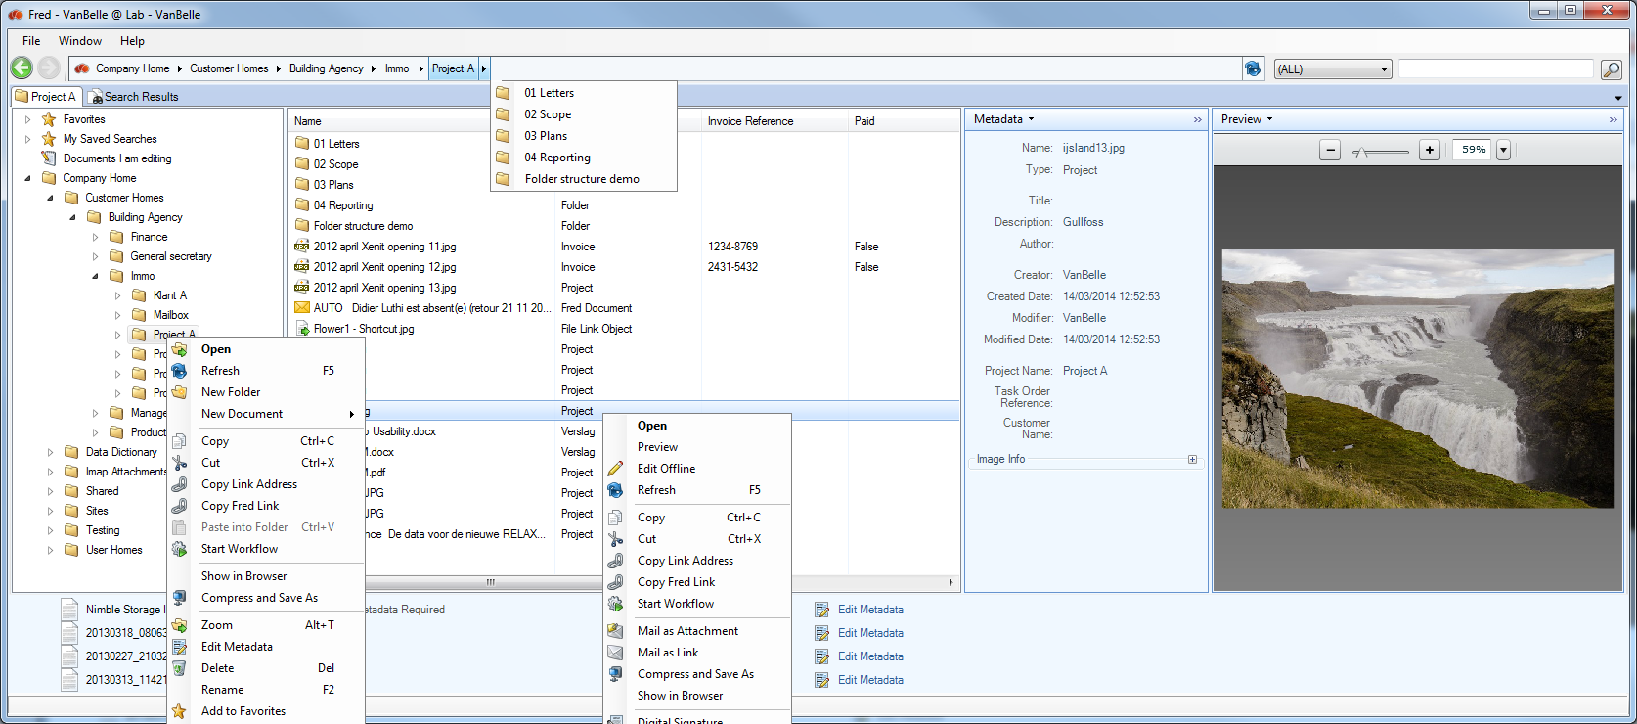

# What is new in Fred 3.2

Following functionalities have been added or modified in this release:

Navigation

* Hiding folders like Data Dictionary, IMAP Attachments, … in the navigation pane

Workflow

* Bulk Metadata Editing: editing the common metadata fields of a selection of documents.

# Installation requirements

Minimum requirement for installing Fred are:

* OS: Vista SP2, Win 7 SP1 or higher
* .NET Framework 4.5
* 90 Mb of available disk space: initial installation and first server

For Outlook 2003:

* PIA 2003 - Primary Interop Assemblies

Convert To PDF: supported for MS Office 2007 or higher

Compare documents: supported for MS WORD 2007 or higher

Metadata auto completion: requires SOLR-based search on the Alfresco server

Facetted search: requires SOLR-based search on the Alfresco server

# Installation instructions

Contact your system administrator for more information about where you can download the Fred Set-up file.

* Download the set-up file to your local disk.
* Open the folder where you downloaded the fred-trial-setup.exe file and double click it.

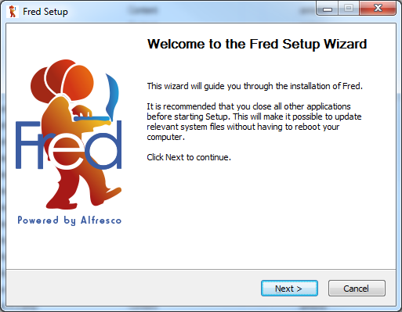

* Click on next.

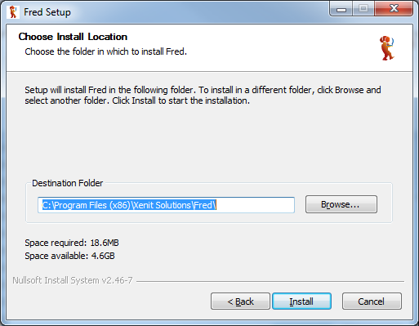

* In case you do not want to use the standard setting, browse to the folder in which you want to install the Fred application. Click on “Install”.
* The application is now being installed.

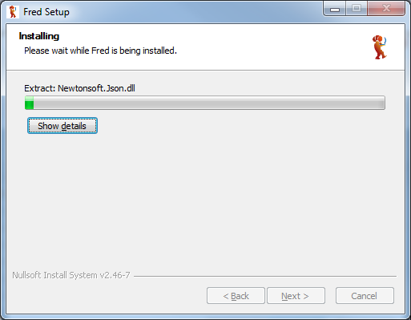

* Click on “Next”

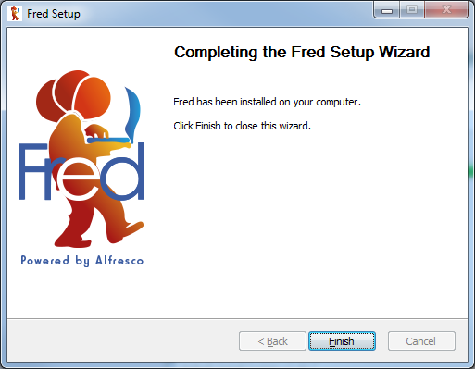

* Fred has been installed. Click on “Finish” to complete the installation process.

In the program menu tree, new commands are now available under the XeniT solutions folder:

* Fred: start the application
* Uninstall Fred: remove the application from your computer

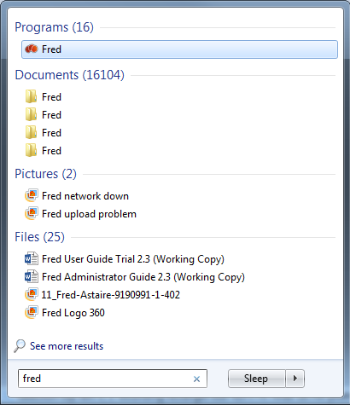

# How to upgrade

New versions of Fred are released on a regular basis. Visit our website regularly to see if new versions are available. Download the new version from the Fred demo site.

Fred compares the compatibility of the front-end and back-end side and provides a message to the user in case of none compatibility.

Important remark: before starting the upgrade process, make sure you have closed the Fred program by using the Exit command on the Fred icon (right mouse click) menu or clicking the.

# About document models and metadata

In a modern Enterprise Content Management platform, files are enriched with metadata making it much easier to search, guide and retrieve information from the ECM platform. Metadata can be any kind of information (text, date, numeric, lists …) that specifies the content or the status of the file. In Alfresco, metadata is organized in the following way:

* A number of document types, each having a particular combination of specific metadata fields, are defined. For example: offer, order, invoice, marketing document, contract …
* Some metadata fields can appear in multiple document types, for example: customer name
* Metadata can be mandatory or optional, single value or multi value …
* Drop down list can be used to provide predefined values for the metadata field
* Constraints can be defined on the format of the field values

The Fred Trial environment provides a sample document model with a variation of document types and metadata field types and constraints. This trial document model will evolve over time to allow you to experience the capabilities of Fred.

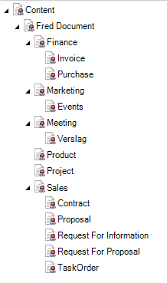

# Getting started

* Click on the XeniT Solutions/Fred command to start up Fred.
* The Fred icon  appears in the task bar and the Fred window is opened.
* Clicking on the Fred icon will open and close the Fred Window.

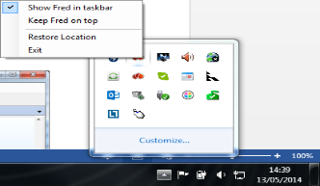

* A right mouse click on the Fred icon pops-up a menu where you can configure the appearance of the Fred application:
* Show Fred in taskbar: presents a Fred tab in the Windows taskbar
* Keep Fred on top: this will make the Fred window appear always on top of any application window you make active
* Restore location: sets the Fred pane back in the bottom right corner
* Exit: close the application

The Fred window can be resized, moved, minimized, maximized and closed. Closing the Fred application can be done with the Exit command on the Fred icon menu, the exit command in File/Quit and the  button.

# Connecting to Alfresco

The Fred Trial Version has a default server configuration. This Fred Trial version cannot be configured for another Alfresco server. The user will have to set the username and password as provided by XeniT.

For the completeness of the documentation we are providing you the functional description hereafter.

Fred is a desktop window to a Alfresco Server. Fred presents the content of the Alfresco server. To be able to access the server, the user needs to configure the Alfresco repository to which the user wishes to connect.

The Fred start-up window contains a list of repositories which you have configured.

* To add a repository click on at the bottom of the list.
* Fill in the fields of the repository you want to configure:
* Repository name: any information to describe the repository.
* Repository URL: the link to the Alfresco repository you want to connect. Contact your administrator to receive the link to your Alfresco repository
* NTLM authentication: use Single Sign-on authentication in a corporate network
* Username and password: in case there is no Single Sign-on available you need to fill in the username and password to authenticate yourself against the Alfresco server
* Click save.

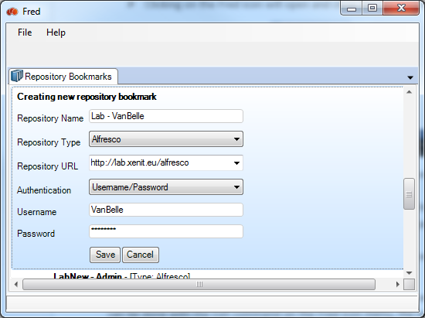

Now this repository is presented in a list of all the repositories you have configured. You can connect to multiple repositories, using multiple account names.

The list of repositories you have configured is sorted alphabetically based on the repository name you have provided.

In the list of repositories you can indicate one repository which will be the default repository. When you start up Fred, it will open the default repository immediately. If no default repository is selected then Fred will open the repository list at start-up.

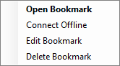

* To enter a repository, you need to double click on a repository in the list.
* When you have entered an Alfresco repository and you want to move to another repository, click File/Disconnect .
* Click on Edit Bookmark to modify the configuration settings of the bookmark
* Click on Delete Bookmark to remove a bookmark from the list
* Click on Connect Offline when you are not connected to the internet and you want to navigate the part of your repository that is in the local cache.

# Alfresco access control

Fred does not create any additional layer on the Alfresco access control functionality. Fred is fully transparent with regards to the access control implemented in Alfresco. Any access rights provided to a user or a group on a folder or a file will be applicable in the Fred application. This means that:

* you will be able to find and see folders and files for which you have at minimum reading rights
* you will be able to create folders when you have collaborator rights or higher
* action commands for which you have permission will be enabled
* etc.

# Browsing the repository

When you have logged in to a specific repository, you will be able to see all folders and files for which you have the appropriate rights.

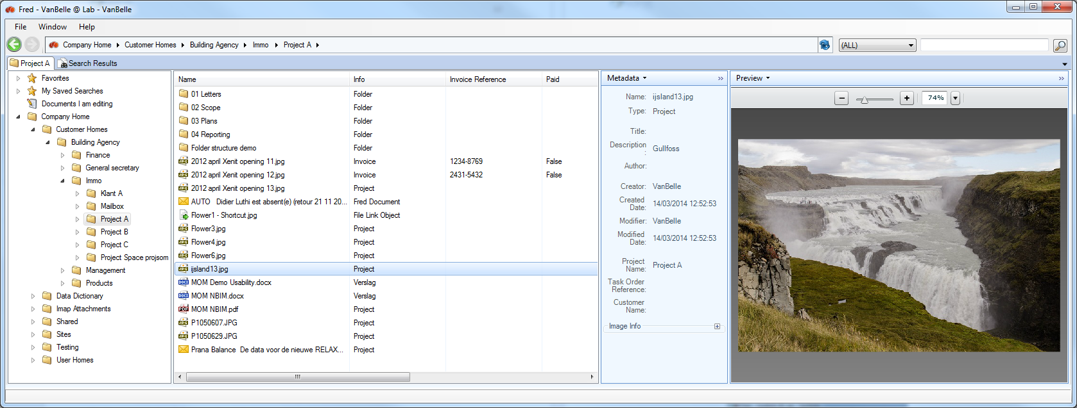

The browser tab has following elements:

* Address bar indicating which folder is the active folder.
* Navigation pane presenting the folder structure in the repository
* Details pane, showing the underlying folders and the files in the selected folder. Columns are showing additional details on the content.
* Metadata pane showing the metadata linked to the selected file or folder in the detail pane
* Preview pane showing a preview of the file selected in the detail pane
* Search box

The behaviour in the Address bar and the Navigation and Detail pane is very similar to the behaviour in Explorer. You can navigate selecting folders in the Address bar, clicking folders in the navigation pane or double clicking folders in the details pane.

## Navigating the folder structure

Clicking on or  symbol will expand resp. collapse folders in the navigation pane.

Clicking on a folder in the navigation pane or double clicking the folder in the details pane or selecting “Open” will set that folder as your workspace. The path of the selected folder will show up in the Address bar.

The name of the Browser tab is updated to the name of the selected folder.

Setting a folder as your workspace allows you to work continuously in the selected folder without having to click through the tree structure. Closing the Fred application, will not change the work space folder when you open Fred again.

Search actions are restricted to your current active workspace.

## Using the Address bar

Clicking on any folder in the Address bar at the top will set the selected folder as working space.

You can use the drop down lists at any place in the path to move to another subfolder in the tree.

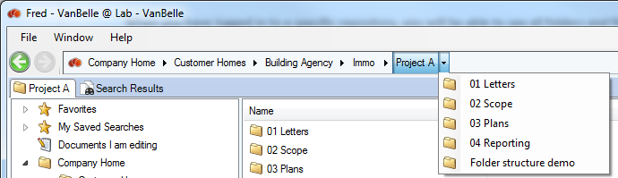

## Back and forward and navigation history

You can use the back and forward buttons, similar to a Windows interface, to browse between previously viewed files and/or folders.

A right mouse click provides a drop down list of previously visited folders.

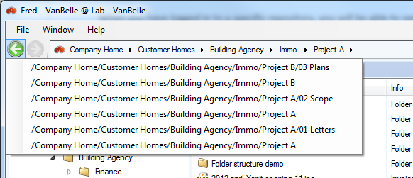

## Favourites

It is possible to add a folder to your Favourites in Fred. You can do this by right clicking on a file/folder, which you want to mark as Favourite, and selecting the “Add to Favourites”. You can also drag and drop a file or folder into the Favourites list.

You can easily rename the folders in the Favourites list by following actions:

* Right click the “Favourite” folder you want to rename and click “Rename Favourite”
* Alternatively, you can also use the F2 button on your keyboard to perform this action
* Or simply click once on the folder name which is highlighted.

Right clicking a Favourite folder provides you the following options:

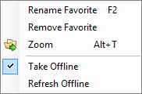

* Renaming the Favourites will not change the name of the original folder.
* You can remove objects from the Favourites list.
* You can “Zoom” into the folder
* You can Take Offline the content in your Favourite folder
* Refresh the content and metadata that is already Offline

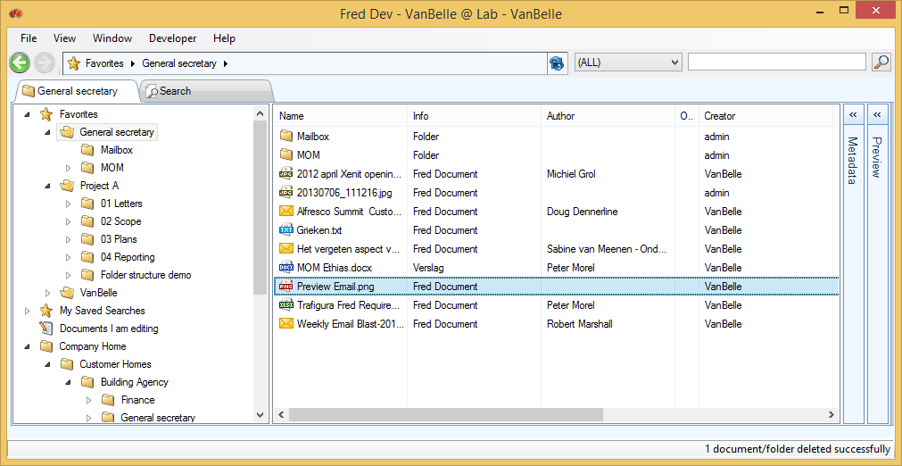

When adding folders to your Favourites, you will be able to navigate in the subfolders of the favourite folders.

You are able to drag & drop documents onto your Favourite folder structure. These documents will be uploaded into the appropriate folder.

Note that the bread crumb at the top will change from the Favourites to the full path indication if you move deeper into the folder structure.

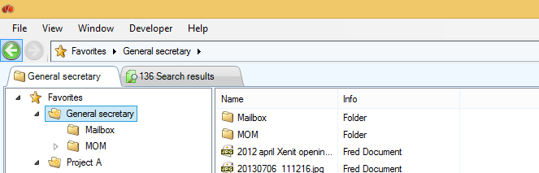

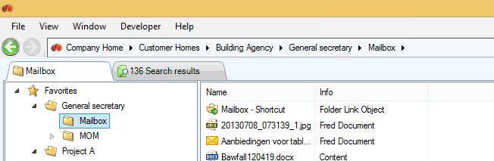

You can start a search query from the Favourite folders. You can launch this from the quick search in the navigation tab or you can select Favourites in the Location field of the Search tab. See also Search

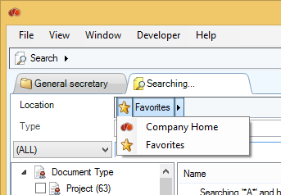

## My saved searches

This folder provides you a list of all search queries you have saved. Clicking on a search will execute that search again and present the result in the Search tab.

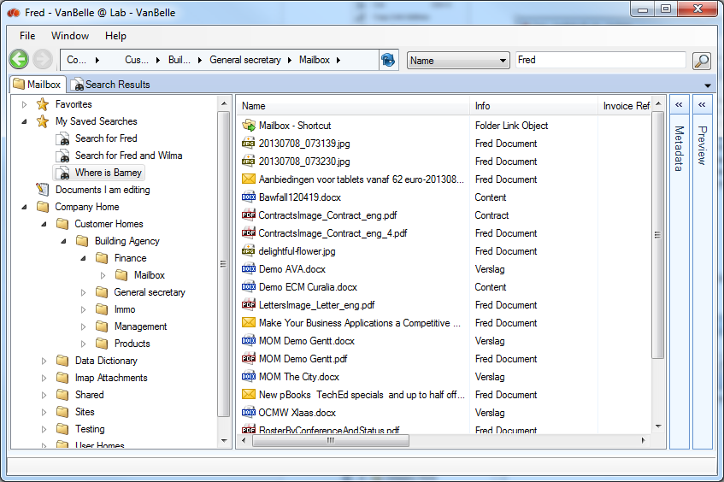

## Documents I am editing

Clicking the ‘Documents I am editing’ provides in the details pane a list of all the working copies in the repository of documents that you have put in Edit Off-Line mode.

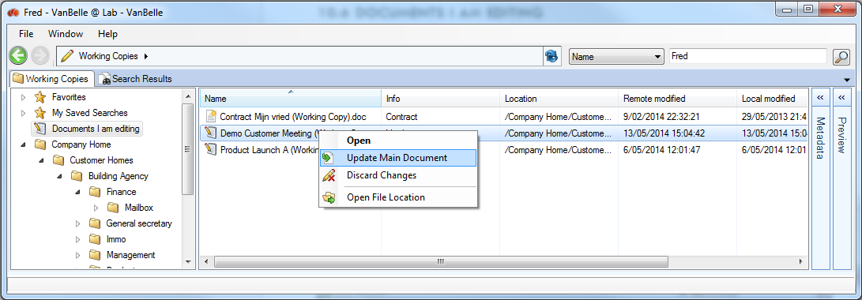

The overview provides you information on:

* An icon indicating the status of the local copy
* The modification date of the local and server copy
* A message on the status of the local copy

Using the right mouse commands you will be able to:

* Open the document
  + In case the working copy is already on your PC, it will open the local copy
  + In case the local copy is missing, it will download the working copy from the server
* Check-in the document at which Fred will take the most recent version of the working copy and check it in.
  + The upload progress of the document will be shown in the upload list
  + In case the document is versionable, the user will get a request to specify the new version.
* Discard the changes at which the working copy will be removed and the original document will be unlocked.
* Open the folder in which the file is located.

## Hiding folders in the navigation (New)

It is possible to hide folders like Data Dictionary and IMAP Attachments in the Fred user interface. These configuration settings are done on the Alfresco Server and have following consequences:

* The folder does not show up in the navigation pane while browsing through the folder structure
* The folder is not shown in the list of objects in the details pane
* The folder will show up in the search tab when you look for it
* You can add the folder as a Favorite or as a shortcut in another folder. This enables you to navigate to the folder in case you need to reach it.

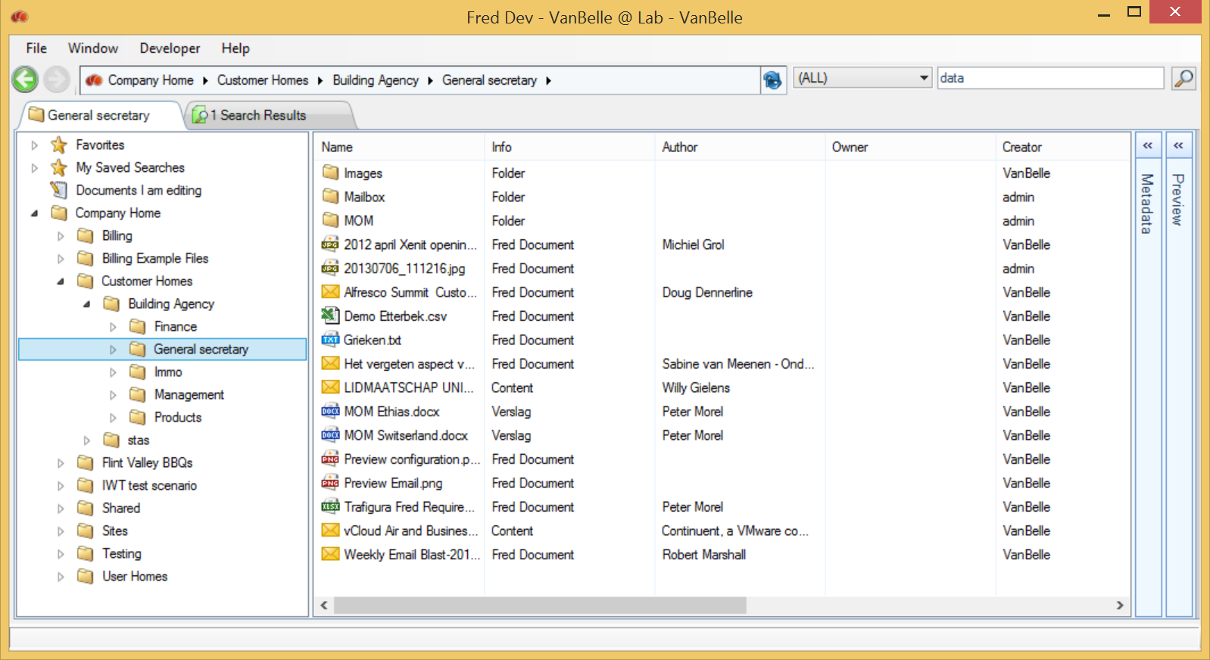

## Opening multiple browser tabs

One can open multiple browser tabs clicking the Window/New Browser Tab command or using the short Ctrl + T. Each browser tab provides a view on the repository. Each tab will have the name of the active folder.

# Handling folders

Right clicking on a folder in the navigation pane or the white space in the details pane pops-up a command menu enabling you to manage the folder structure.

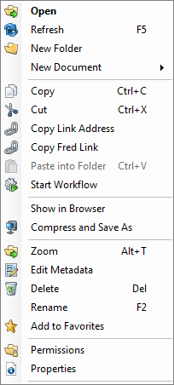

If you do not have the appropriate rights to execute one of these commands, this command will be disabled.

## Refresh

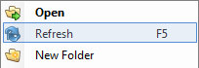

When opening a folder for the first time (or after a certain time span), Fred will query the Alfresco repository and present the contents of the folder. When another user is concurrently adding or editing content in the same folder, updates are only presented in your Fred window when you force (F5 or menu) a refresh of the folder content or after a certain time span, when the folder is reopened. This will update the sub folder list, the list of files and its meta-data in the details pane.

## Create folders

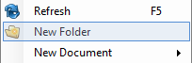

* To create a new subfolder, click “New Folder”.
* Enter the name of the new folder and Enter.

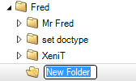

This functionality is not available for Share sites folder as this is a part of the repository that needs to be set-up through the Alfresco Share interface.

## Rename folders

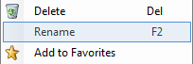

* To rename a new subfolder, click “Rename”.
* Enter the new name of the folder and push Enter.

## Metadata of folders

See 15 Handling metadata

## Move folders

By simple drag and drop you can move one or more folders to any location in the tree. You can move folders within the Navigation pane or you can move folders from the detailed pane to the navigation pane. You are prompted to confirm you want to move the folders.

Notice that you need the appropriate rights to execute a move. You will need at minimum folder creation rights in the receiving folder **and** folder deletion rights in the original parent folder.

## Delete folder

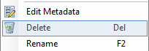

* To delete a folder, click Delete 

You will be able to restore the folder by clicking on Window\Recycle Bin. See 19.2 Recycle bin.

## Copy folder link

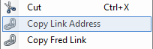

You can copy a link with the folder address to an e-mail or a document. Provided the receiving party has access rights, clicking the link will open the Alfresco Browser and show the folder and its content.

## Copy Fred Link

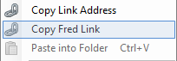

This copies a link which will open up a new tab in the Fred application which will have the folder highlighted in the detail pane.

<fred://a1d07cd6-2f5f-4983-99ae-c11f398107dd/browse/id/workspace/SpacesStore/fca9579b-e239-419a-b6cc-40e8f8ec6634>

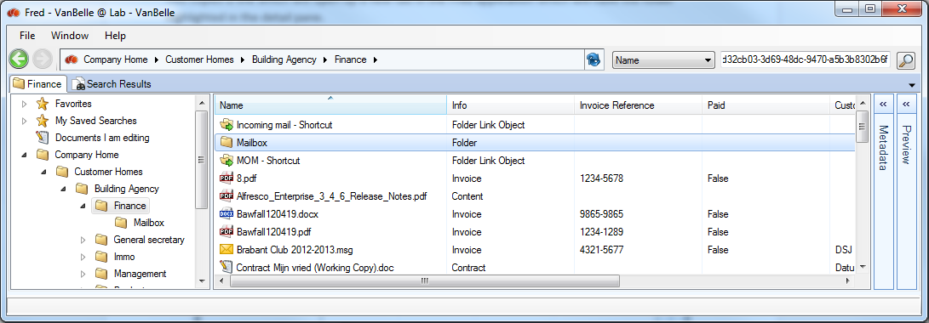

You can paste the Fred link as a hyperlink into a document or an e-mail by inserting a hyperlink and pasting the Fred link into the address field.

## Create a New document

“New Document” will allow you to create a new document in Fred from templates previously defined on the Alfresco server.

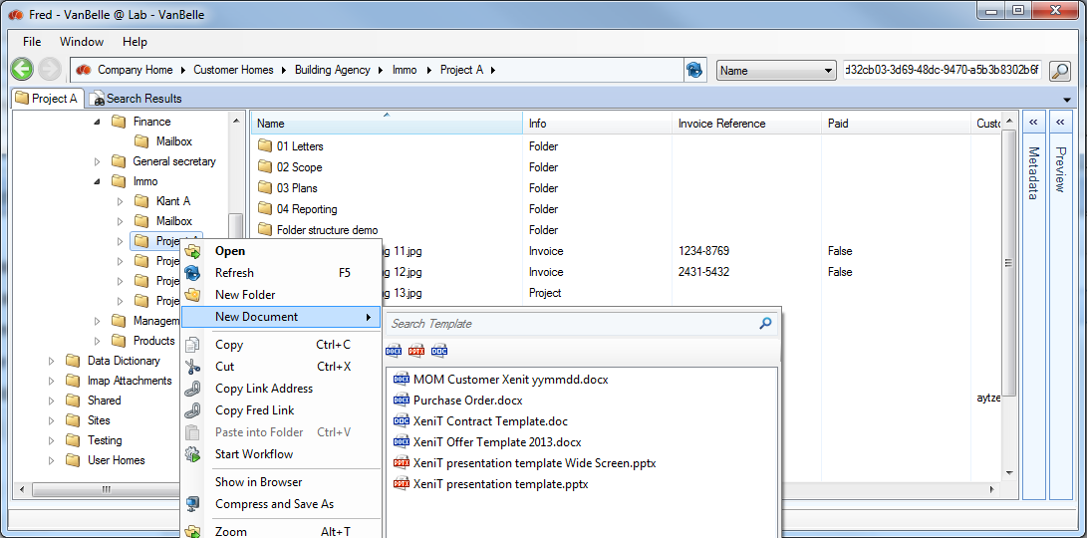

New template documents can be added by the Administrator or the user with the appropriate rights. Once a template document is added to the folder Company Home/Data Dictionary/Document templates, it becomes generally available to the users.

You can set document type and metadata values for the templates. The documents created from the template will automatically inherit the templates’ metadata.

## Show Folder in Alfresco browser

The Show in Browser command enables you to jump from Fred to the Alfresco Share (or alternative Explorer) interface

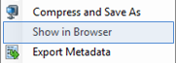

This enables you to view more folder details and use all Alfresco functionality available through the Share interface.

## Print documents

You can select one of multiple documents and print these on the default printer configured on your local PC.

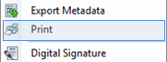

## Paste into folder

When you copy a file from your desktop this command will be enabled. You will be able to paste the file (CNTRL + V, Paste into Folder) into the selected folder.

To clone a document from Fred into the same location or another folder in Fred you need to:

* Select the file and click Copy on the file menu (see 14.4 Copy Document)
* Select the folder in which you want to paste the link to the document
* Click “Paste into Folder” in the Folder menu

Cloning the document into the same folder will create a *‘document_name –Copy.docx’*. Cloning it into another folder creates a *‘document_name.docx’*.

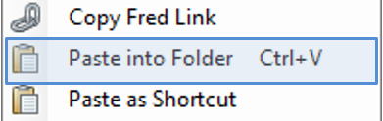

## Paste as shortcut

To paste a link to a document into another folder you need to:

* Select the file and click Copy on the file menu (see 14.4 Copy Document)
* Select the folder in which you want to paste the link to the document
* Click “Paste as Shortcut” in the Folder menu

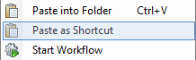

Notice that in the Info Column, the file is indicated as ‘File Link Object’. If you want to see the details of the document, double clicking the file will make it jump to the folder in which the document is located and show the metadata details.

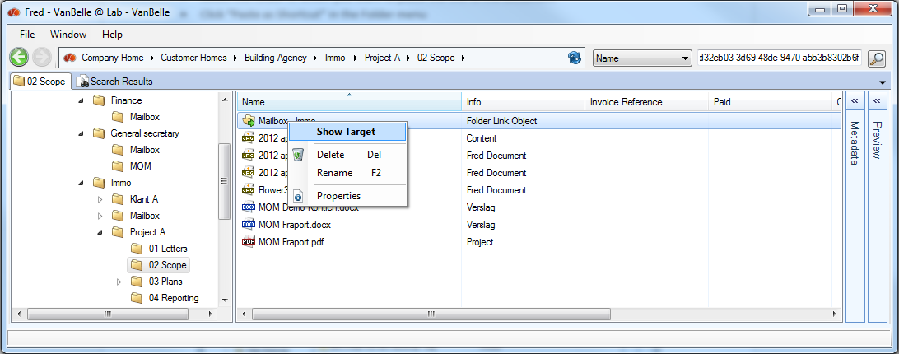

## Folder permissions

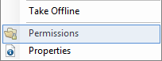

This function is only available on those folders for which the user has more than consumer rights.

By clicking “Permissions” on the folder menu, a new tab will open and display the users and group rights set on this folder. The table indicates which rights are set for which users, if the user receives the right through the group, if the rights were inherited from a parent folder and the Authority Type.

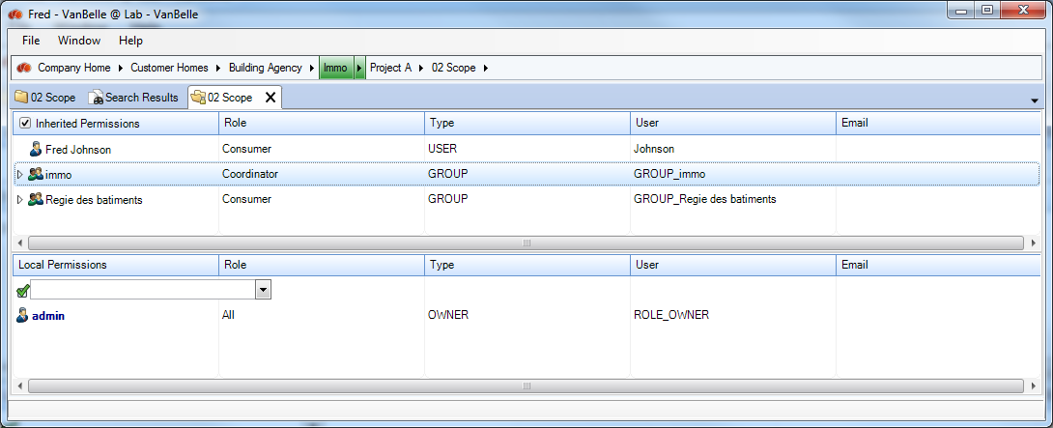

The upper part of the screen is showing the permissions that are inherited from the parent folders up to the company home folder.

The lower part of the screen is showing the permissions that are set on the selected folder.

Permissions are set for users or groups. Selecting a user or group will highlight (green) in the breadcrumb the folder in which the permissions are set.

You can click on the folders in the path to see how the rights are set in the folders above.

You can set permissions for users or groups in the Local Permissions part. Click into the cell if you want to add a user. Type a name and the list of the matching users or groups appears.

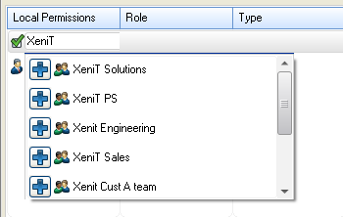

Click on  to add a user/group. The name is now listed in the local permissions table and you can define the role.

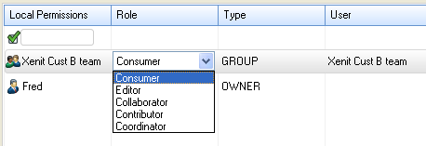

If you don’t want this user to have access to the folder anymore, right click on his name and select “remove permission”.

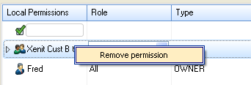

## Multi folder functionality

One can select multiple folders in the detail pane. Some commands in the folder menu are available when you select multiple folders.

# Taking content off-line

You can take part of your repository off-line. In the off-line mode you will be able to navigate through your off-line structure, view the related metadata and open the documents you have taken off-line.

## Selecting the content you want to take off-line

There are two ways you can take folders off-line:

* Via the menu of the Favourite Folders



* Via the menu of the folders: when you take off-line a folder in the repository, it is automatically added to your Favourites after the synchronisation has been completed

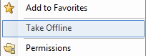

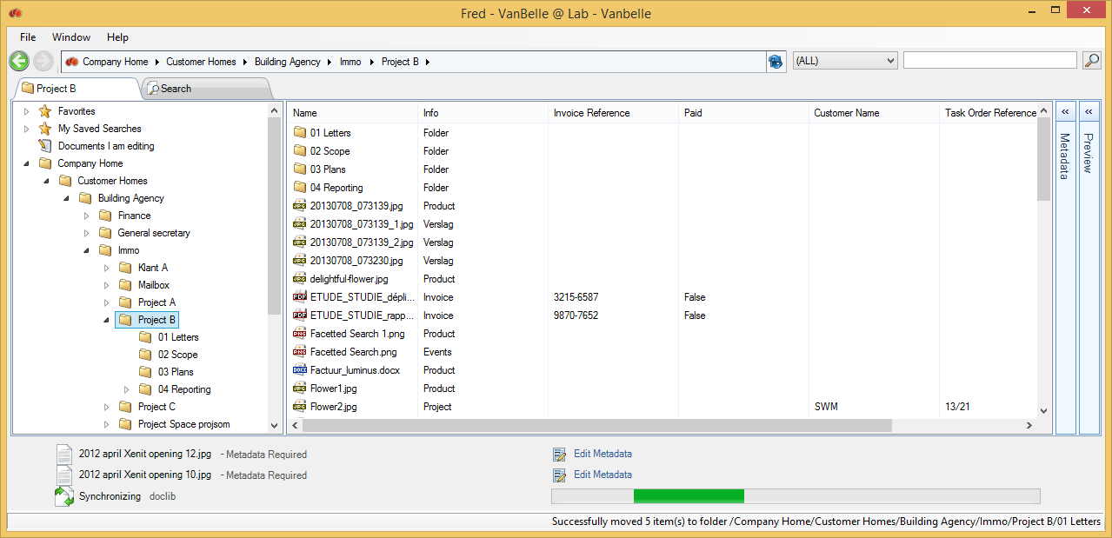

While synchronising, there is an indication that the process is running.

When completed, the folder is visible under the Favourite Folder and is marked with a .

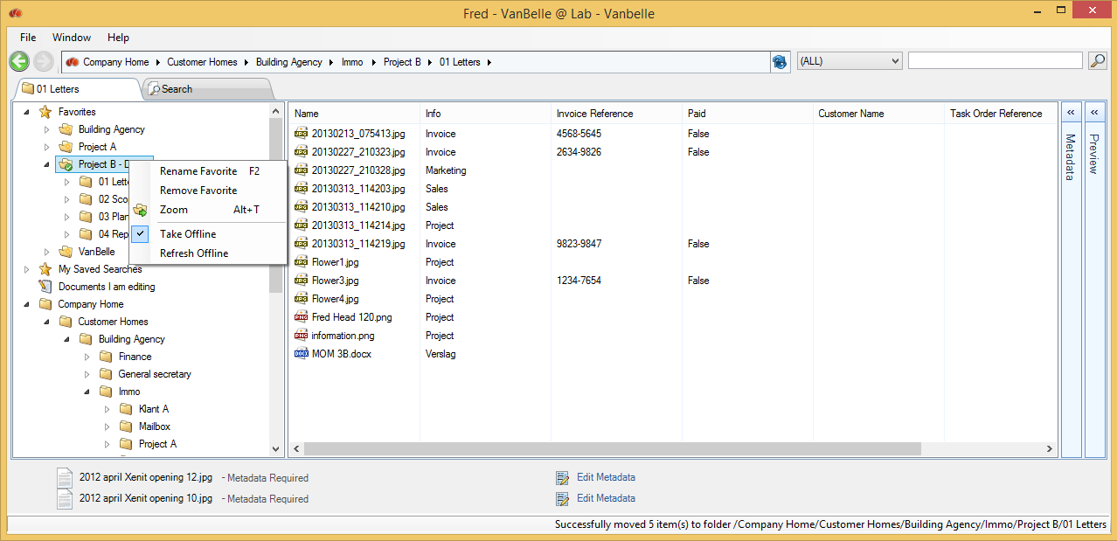

## Refreshing the off-line content

When you are on-line, you can update the off-line content with the newest content available on the server. Fred runs a validation check and only updates the content that has been changed on the server since the previous synchronisation.

## Deactivating Off-line sync

If you want deactivate the off-line sync mode, you need to uncheck the ‘Take Off-line’ command in the Favourite folder.

## Working in Off-line mode

When you are off-line, you can connect to the local repository via the Bookmarks menu. First make sure to disconnect clicking the File/Disconnect menu. In the list of repositories, right click the bookmark you want to connect to and select Connect Off-Line.

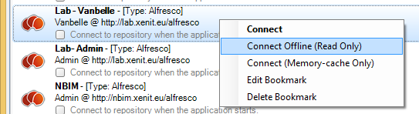

When you are connected you will be able to navigate in the substructure which has been synchronised.  
Only part of the menu commands will be available.

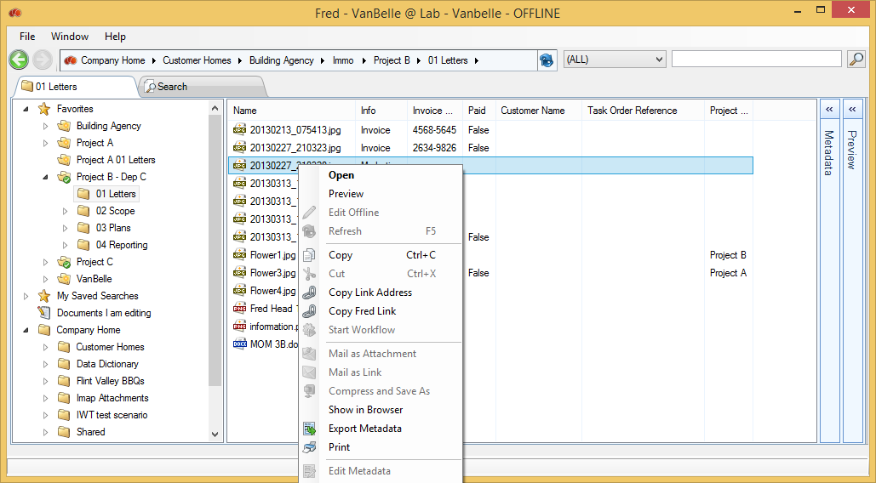

You will be able to:

* Open the documents
* Copy a document and paste it to your desktop
* Copy a link to the document and paste the link in another document or an email
* Export the metadata which was synchronised
* Print the document to your default printer
* Zoom into a folder
* Add a folder to Favourites

# Adding content to and getting content from the server

## Uploading fileS

You can simply add any kind of file to the Alfresco repository by dragging and dropping the file from the desktop application onto any folder in the Fred window.

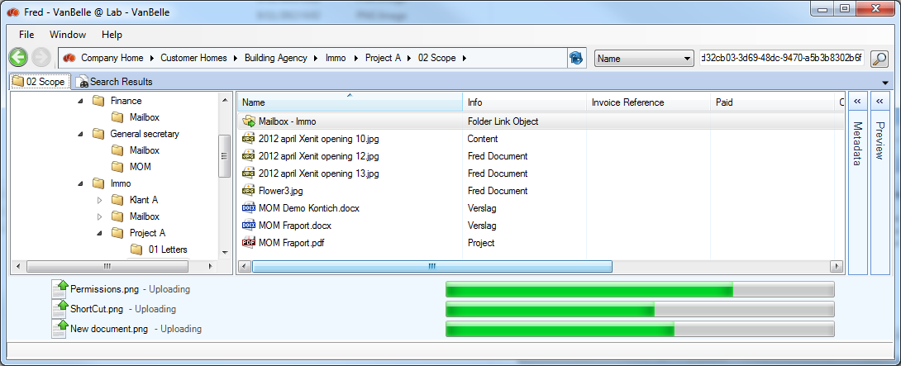

The file will be uploaded into Alfresco. You can drop multiple files at once or multiple single files. While the documents are uploading, you can continue to navigate and work in Fred.

Uploaded documents are listed in the upload pane. Once uploaded, you will need to complete the metadata of the file. In case the document has a general nature, you can use the base document type selected by default.

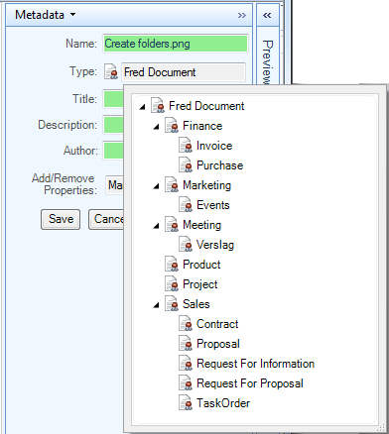

Based upon the document type selected, a set of metadata fields will appear. According to the rules defined by your organization, some fields might be mandatory and others might be optional. In the case below the document type is a Proposal and the required fields (*) are Proposal Reference and Proposal Status.

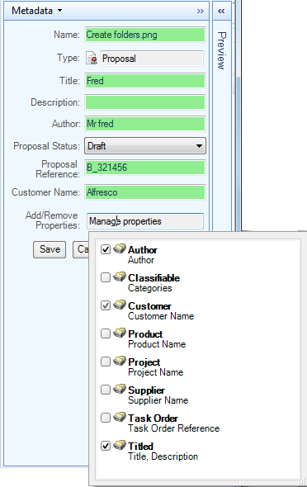

At the bottom of the metadata field related to the document type, a list with optional groups of metadata fields is presented. It is for the user to judge if these optional metadata fields are relevant to the document and if it should be added to the document.

* Click on “Save” to finish the uploading of the file into the Alfresco repository.

Note:

* Mandatory metadata field are indicated with a “*”
* Metadata fields with format restriction are coloured red when the input does not comply with the restrictions.
* You will not be able to save the document if the metadata fields with restrictions are not filled in correctly.

Following applications allow drag and drop of content into Fred and are tested and supported by XeniT:

* Desktop
* MS Explorer
* MS Outlook 2003, 2007, 2010

Other applications might support the dragging and dropping of content as well and could be able to interact with Fred. By checking if the application allows dragging and dropping of a file (including content) into MS Explorer or onto your desktop, you can test the compatibility. Next step is to test the dragging and dropping into Fred.

## Uploading folders

One can upload folders from your desktop or explorer by dragging them into Fred. An upload process will start which indicates the number of subfolders and files that need to be/have been uploaded. In this process, the user does not get an indication that metadata needs to be edited to complete the upload process.

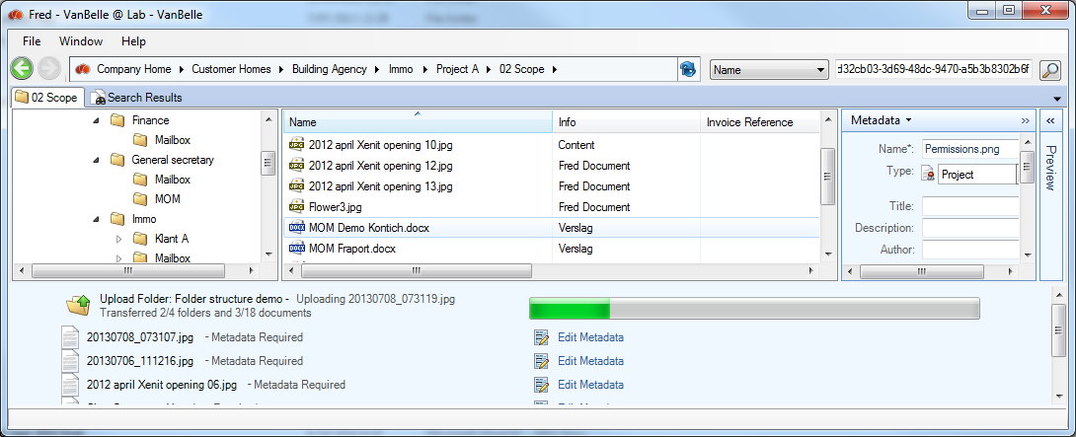

Important remark: it is only possible to extend a folder structure while uploading a folder. It is not possible to refresh/update the structure and content from a folder you copied already to Fred.

Adding documents, individually or in group, to an existing folder structure is supported and one can extend the folder structure while dragging a new subfolder structure into Fred.

## Compress documents and folders to a container on your local drive

You can select one or multiple documents and/or folders and compress then into a container which will be saved on your local disk.

* Select the files you want to compress.
* Right mouse click and select “Compress and Save as”

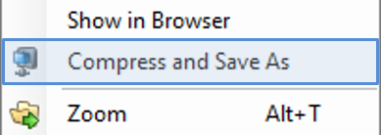

* A browser window will pop-up asking you to select the folder and name under which you want to save the container

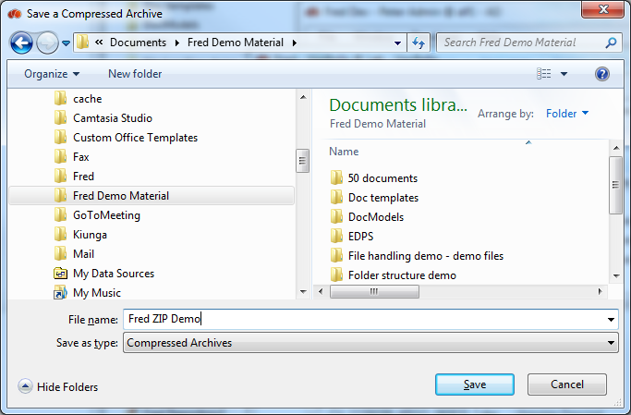

* Fred will provide a message “Successfully Saved Compressed Files”
* The container with the compressed files is available where you have saved it

Selecting a folder will compress all content in the folder, including the sub-folders and its content.

# Handling Documents

Right clicking on a file pops-up a command menu enabling you to manage the document.

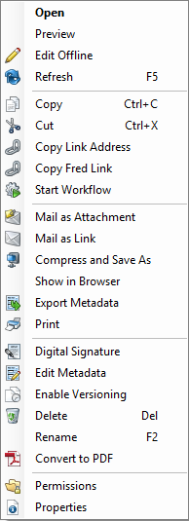

## Open document

Files can be opened directly from Fred by clicking the “Open” command or by double clicking the file. The file will be downloaded to a local copy and opened with the corresponding application.

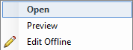

## Document metadata

See 15 Handling metadata

## Move document

By simple drag and drop you can move files to any location in the tree. Notice that you need to have the appropriate rights to execute a move. You need at minimum file creation rights in the receiving folder **and** file deletion rights in the originating parent folder.

## Copy Document

Copying files in Fred will make a copy on the desktop clip board. You can paste the document to any application on your desktop.

A second way for copying files is to drag and drop from the Fred window onto another application window (ex. Explorer, Word document, an e-mail …).

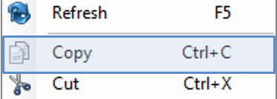

## Copy a file link

Provided that the receiving users have access to the Alfresco repository, it is more appropriate not to copy the file into an e-mail communication but to copy a link to the document using “Copy Link address”, by right clicking on the file. This avoids the multiplication of identical information in the organization.

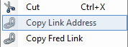

## Copy a Fred Link

This action copies a link which will open up a new tab in the Fred application which will have the folder highlighted in the detail pane.

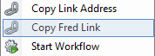

<fred://a1d07cd6-2f5f-4983-99ae-c11f398107dd/browse/id/workspace/SpacesStore/e0348edb-24ff-458a-9f79-1828b4bd1161>



## Mail as attachment

“Mail as attachment” allows you to send a document as attachment by email, directly from Fred.

The document will automatically appear as an attachment in a new email.

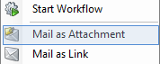 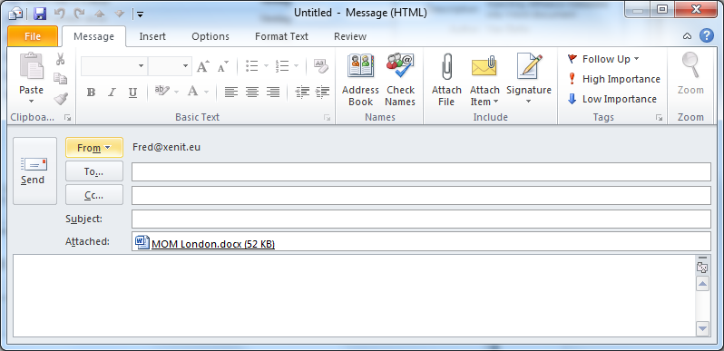

## Send document link via Email

“Mail as Link” allows you to mail a link to a certain file or folder in Fred. Provided the receiving party has access rights, clicking the link will open the Alfresco Browser and show the file/folder and its content. By doing so, you will avoid multiplication of documents.

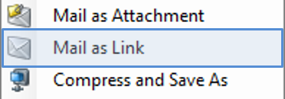 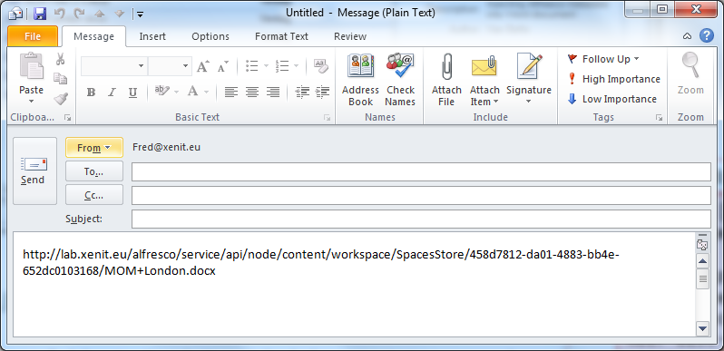

## Rename file

* To rename a file, click “Rename”.
* Or push the F2 key
* Or one can click once on the highlighted file.
* Enter the new name of the file and push Enter.

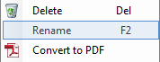

## Delete files

To delete a file click “Delete”. If you do not have the appropriate rights, this command will be disabled.

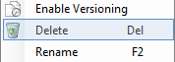

You can delete a selection of multiple files.

You will be able to restore the file by clicking on ‘Window\Recycle Bin’. See 19.2 Recycle bin

## Refresh metadata

The metadata in the columns in the details pane or in the metadata pane are metadata of the specific time when you visited this content. If another user has updated the metadata, this will be updated in your view the next time you refresh the folder content (see 11.1 Refresh) or in the metadata pane when you reselect the document. You can enforce a refresh of the metadata by clicking “Refresh” or F5 on the folder or the file.

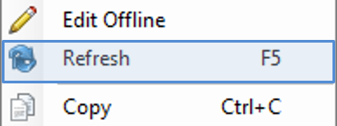

## Locking, Check-out and check-in documents

Locking a document will prevent others to upload new versions of the document. Users will still be able to preview and download the document.

Check-out and check-in are two important functions in a Document Management System (DMS):

* Check-Out: you are locking the document for other users and make a “Working Copy” of the document to be edited. The users will still be able to open the locked document, but they will not be able to modify the document on the Alfresco server. You will be able to modify the “Working Copy” of the document
* Check-in: when you have finished the modifications on the document, you can check-in the document into the original document. This will update the original document, remove the “Working Copy” and unlock the original document. Now the document is again available to others for modification.

## Edit offline

The edit offline command combines a Check-Out and the download/opening of the working copy.

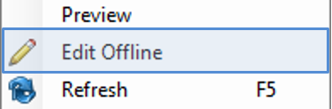

The Edit Offline command in Fred will:

* Lock the document 
* Create a working copy  of the original document
* Download that working copy to your local drive
* Open the working copy for editing.

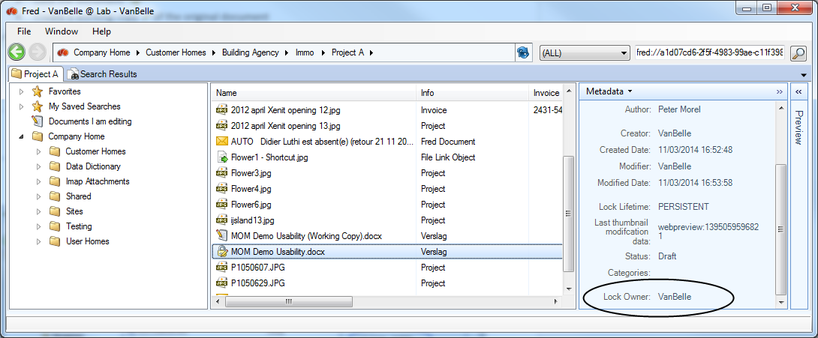

The working copy is copied to a Fred folder on your local hard drive. This folder is defined in settings (repository tab) of Fred.

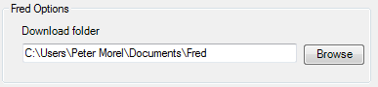

After editing the document you can simply save the local working copy of the document without indicating where you are saving the document.

When you want to continue working on the working copy after you have closed the local copy, you can reopen the local copy by double clicking the working copy in Fred or by clicking the “Open” command.

You do not need to drag and drop or upload the working copy to Fred. With the “Update Main Document” command you will:

* Upload the local working copy to Alfresco
* Update the master (locked) document with the new edited document
* Unlock the master document

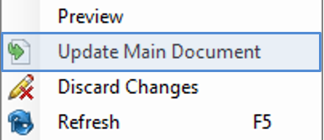

With the Discard Changes command you will be able to unlock the main document and remove the working copy including any changes you have applied to the document.

## Pushing metadata from the Alfresco server into Office documents

Fred enables you to write Alfresco metadata values to metadata fields in office documents (MS Office, Open Office). Changing metadata values in Alfresco will change the value in the related metadata field in the document. Prerequisite is that the naming of the metadata field in the document template are the same as in the Alfresco document model.

You can create a document template which uses metadata fields to create the content. Using the above described mechanism, one can further automate/assist the creation of documents. Some examples: creation of a corporate document reference number, meeting date, meeting subject, ...

Take contact with your Fred IT team to configure this functionality at the server side.

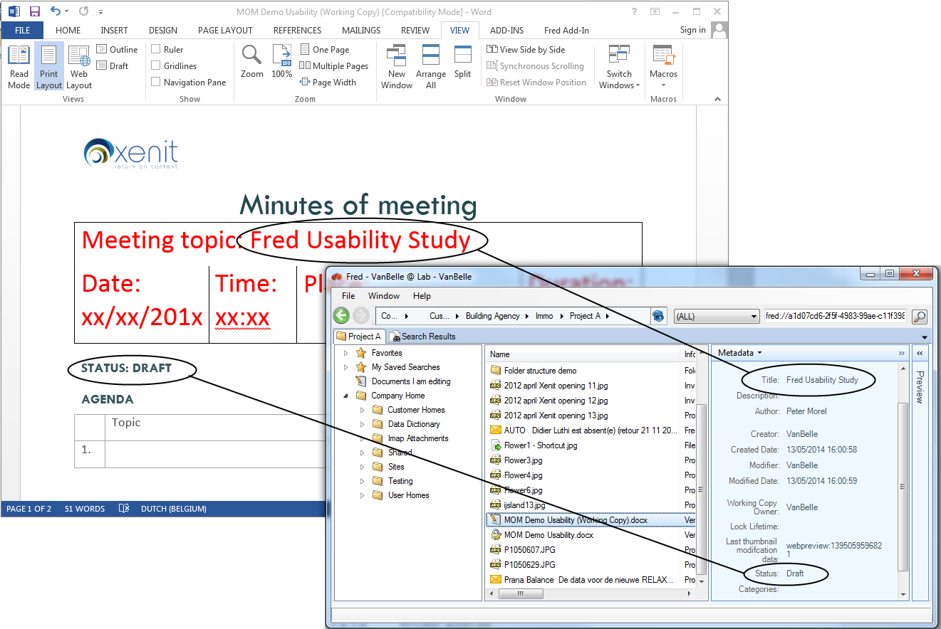

## Word Add-in

It is possible to download and install a Fred Word Add-in. This Add-in shows you all the business metadata which is pushed from Alfresco into the document.

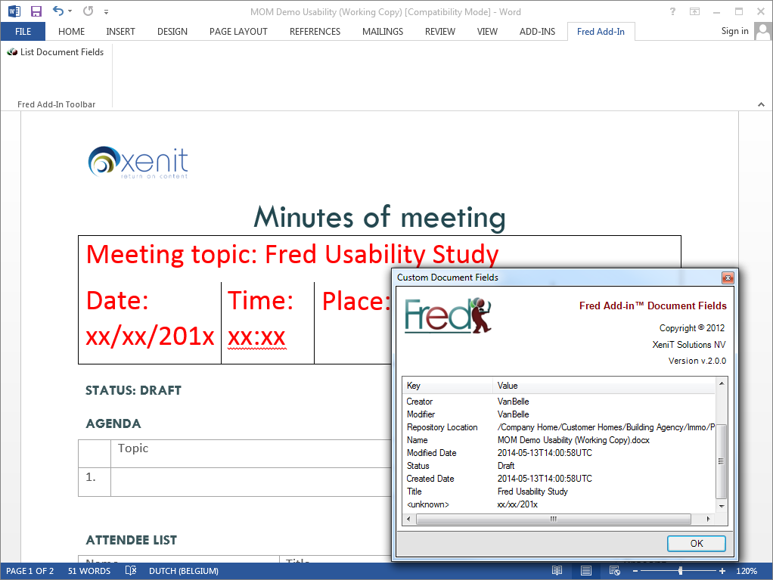

## Convert to PDF

The Convert to PDF command is available for MS Office documents and converts the document into a PDF version using the MS Office application on your desktop.

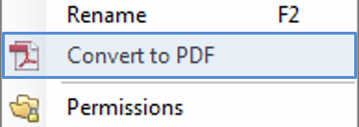

A PDF version of the document is made available on Alfresco in the same folder.

## Preview document

There are multiple options to preview a document:

* Flash preview as provided by Alfresco Share including the formatting of the document
* Image preview of the first page
* Text preview without formatting. The text is selectable.
* Html preview for outlook email files.

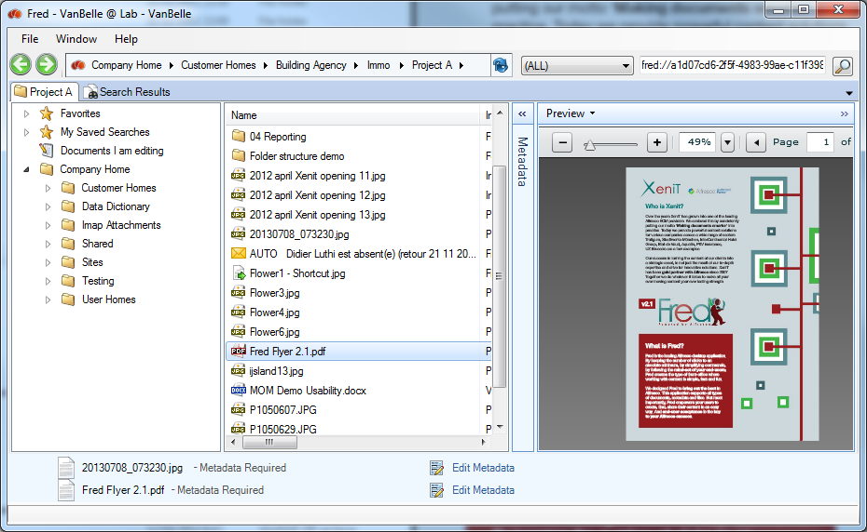

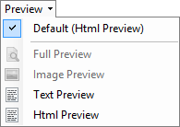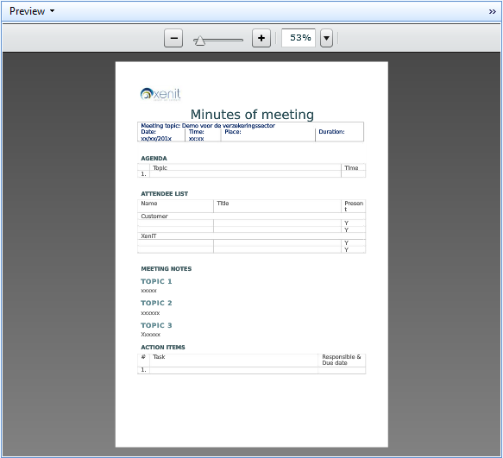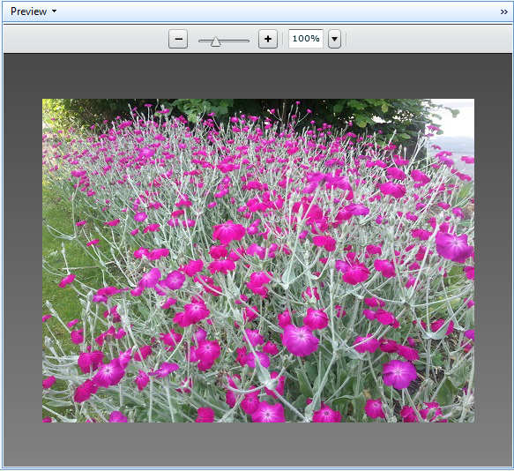

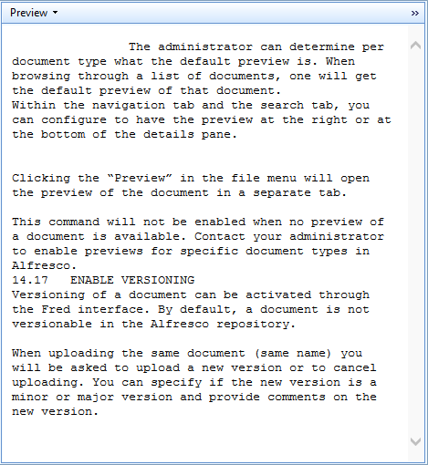

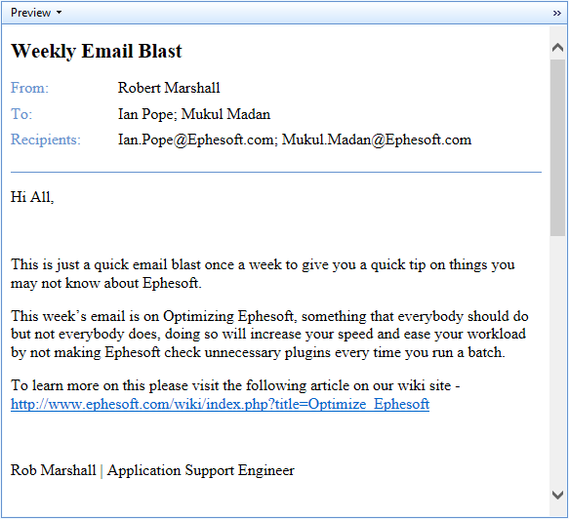

The administrator can determine per document type what the default preview is. When browsing through a list of documents, one will get the default preview of that document.

Within the navigation tab and the search tab, you can configure to have the preview at the right or at the bottom of the details pane.

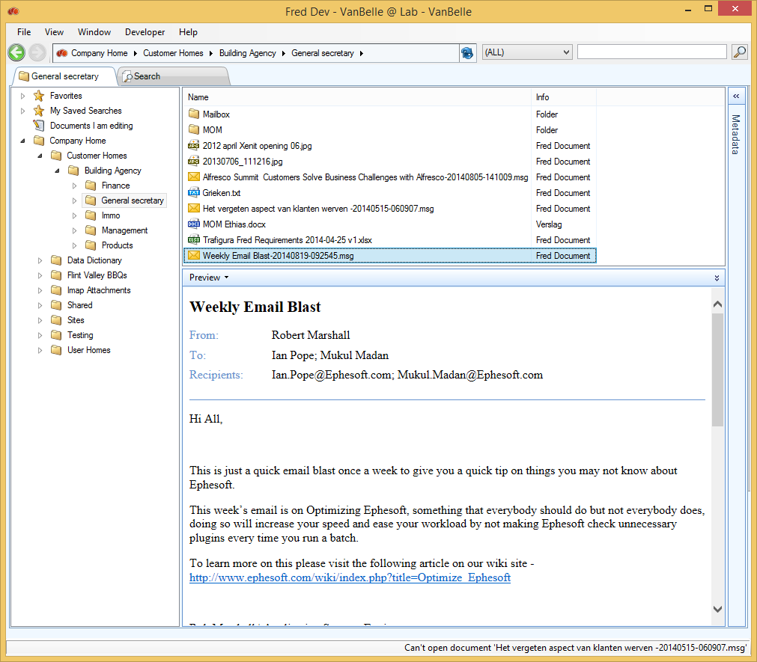

Clicking the “Preview” in the file menu will open the preview of the document in a separate tab.

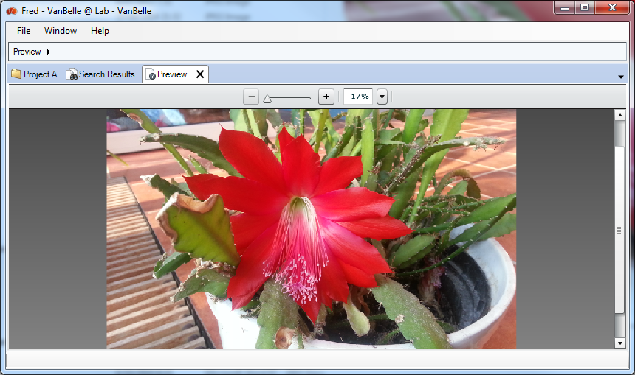

This command will not be enabled when no preview of a document is available. Contact your administrator to enable previews for specific document types in Alfresco.

## Enable versioning

Versioning of a document can be activated through the Fred interface. By default, a document is not versionable in the Alfresco repository.

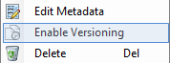

When uploading the same document (same name) you will be asked to upload a new version or to cancel uploading. You can specify if the new version is a minor or major version and provide comments on the new version.

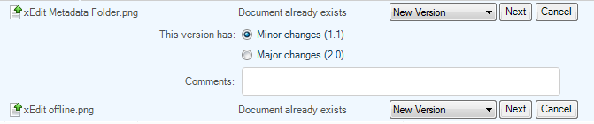

## Show version history

Once a document is made “versionable”, the command “Show Version History” becomes available.

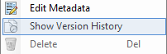

With this command you can see the list of all versions of the document. Every version can be opened individually. You cannot upload documents in this list.

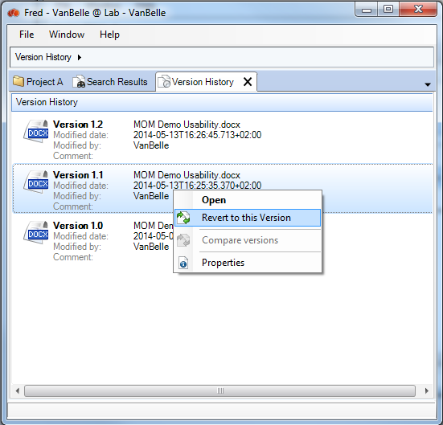

You can revert an older version of the document to the most recent version. This will create a new version.

## Compare WORD documents

You can compare two version of a WORD document. When selecting two version of a specific WORD document, the Compare Version command will be enabled.

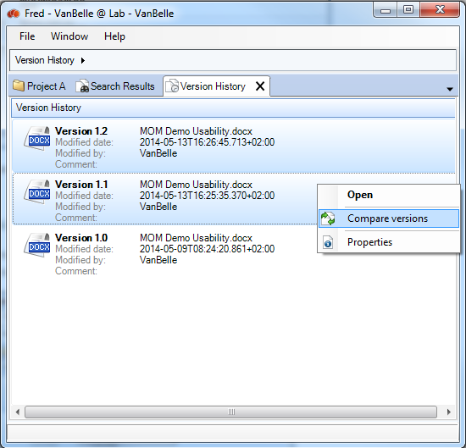

The Compare versions command will download both version and use the WORD application on your desktop to compare the two versions.

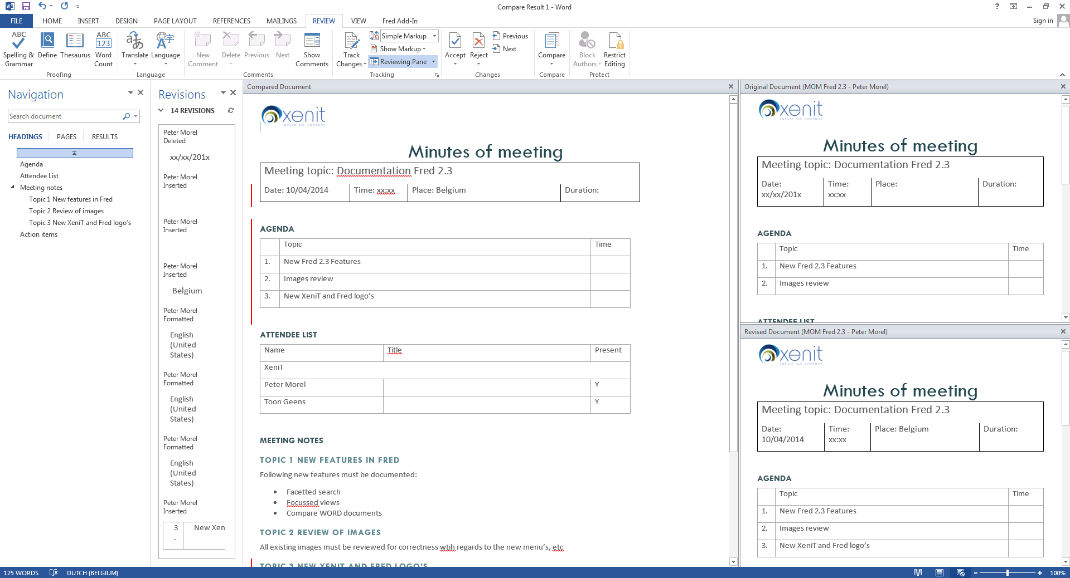

## Show File in Alfresco browser

The “Show in Browser” command enables you to jump from the Fred window to the Alfresco Web interface. This enables you to view more file details and use all functionalities available in Alfresco.

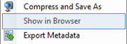

## File permissions

Similar as to Folder permissions, you can read and set permissions on files.

See “11.14 Folder permissions” for more information.

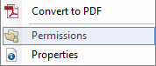

## Multi document functionality

Some commands in the file menu are available when you select multiple folders: “Open”, “Edit Offline”, “Copy”, “Cut”, “Copy Link Address”, “Mail as attachment”, “Mail as Link”, “Show in Browser”, “Delete”, “Properties”, for all the selected documents.

## Using shortcuts

A full list of the shortcuts available:

* Ctrl+C= Copy file/folder
* Ctrl+X= Cut file/folder
* Ctrl+V= Paste file/folder
* Ctrl+A= Select All
* Ctrl+Q= Quit application
* Ctrl+F= Quick search in Fred
* Ctrl+T= Add new tab
* Ctrl+A= Select all objects in the detail navigation pane or in the details search pane
* Del= Delete file/folder
* F2= Rename file/folder
* Backspace= Previous menu
* Alt+arrow left= Go to previous menu or submenu
* Alt+arrow right= Go to next menu or submenu

# Handling metadata

## Viewing METADATA of folders

You can view the metadata linked to a folder in the Metadata pane. The metadata appears when you select a folder in the navigation pane or in the details pane.

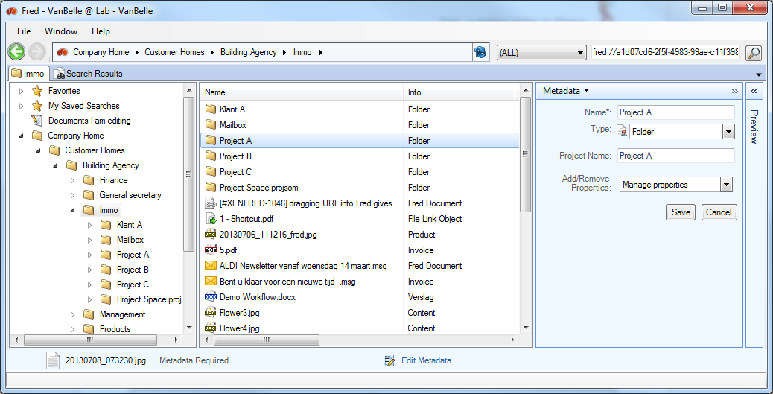

## EDIT METADATA of folders

* To edit the metadata fields of a folder, click “Edit Metadata” in the metadata pane.

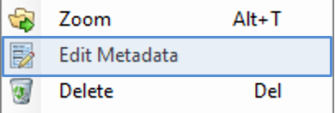 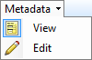

## Viewing Document metadata

Metadata of files and folders are presented in the Metadata pane. As you scroll through the list, data in the metadata pane will be updated.

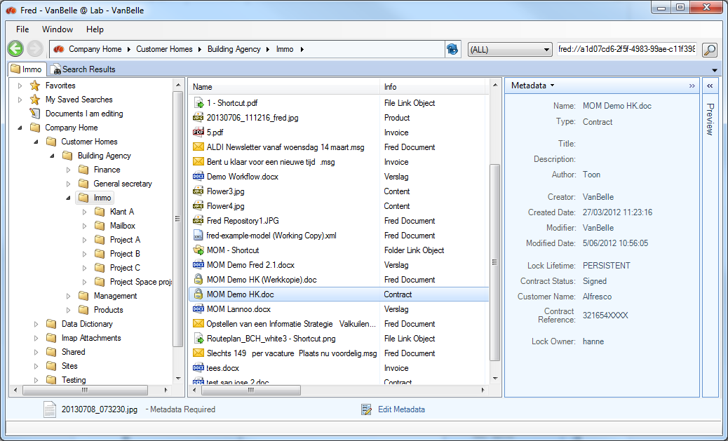

In the example above you will see that this Document type is an “Project” which has the standard metadata field (creation date, creator, …) and some specific metadata fields(project name, customer name, …).

## Edit Document metadata

“Edit Metadata” will open the window to edit the metadata field values. You can further detail the document type and/or add additional optional metadata groups. These steps are described in 13.1 “Uploading file”.

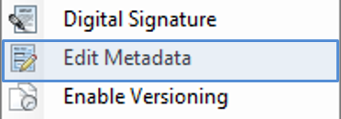 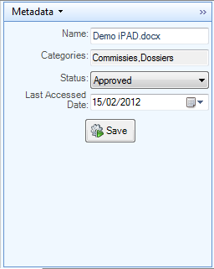

## Auto completion of metadata values (SOLR)

When the Alfresco server is using SOLR indexing, then one can activate the text metadata field to have auto completion behaviour. While you are typing, Fred will suggest possible values that fit the text you are typing. As you have narrowed down the options while typing, you can select with the mouse or with the keyboard arrows the correct value and move to the next field.

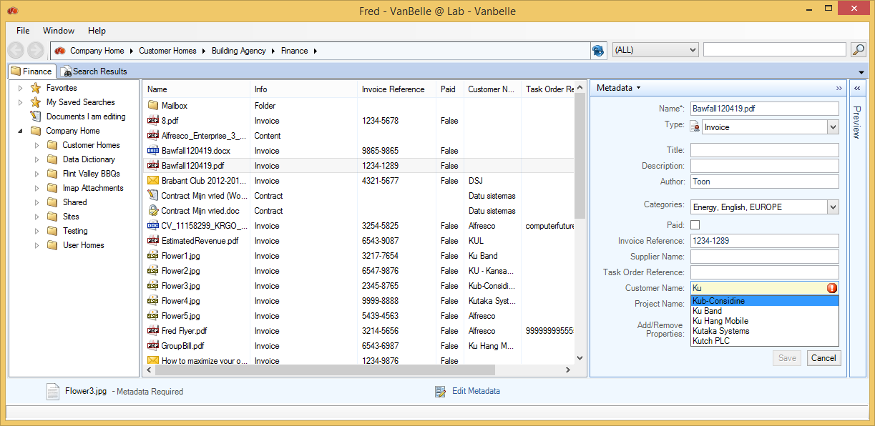

Important remarks:

* The Auto suggestion is case sensitive!
* When you add a new value to the filed, it will take some time before this value will appear in the suggestions. The delay is dependant of multiple elements specific to your environment. In ideal conditions it can be as short as 15 sec.

## Viewing metadata of Multiple documents

All metadata fields, as defined in the Alfresco document model, can be selected as a column in the Fred window. This allows you to sort the files. See ‘16 Handling views’ for more information.

## Editing metadata of Multiple documents (New)

Selecting documents in the details pane will show the metadata fields which are common for the selection in the metadata pane. In case all fields are blank or have identical values, they will be presented in the view mode. In the view mode of the metadata pane, fields which have different values in the document selection will be marked as ‘Multiple values’.

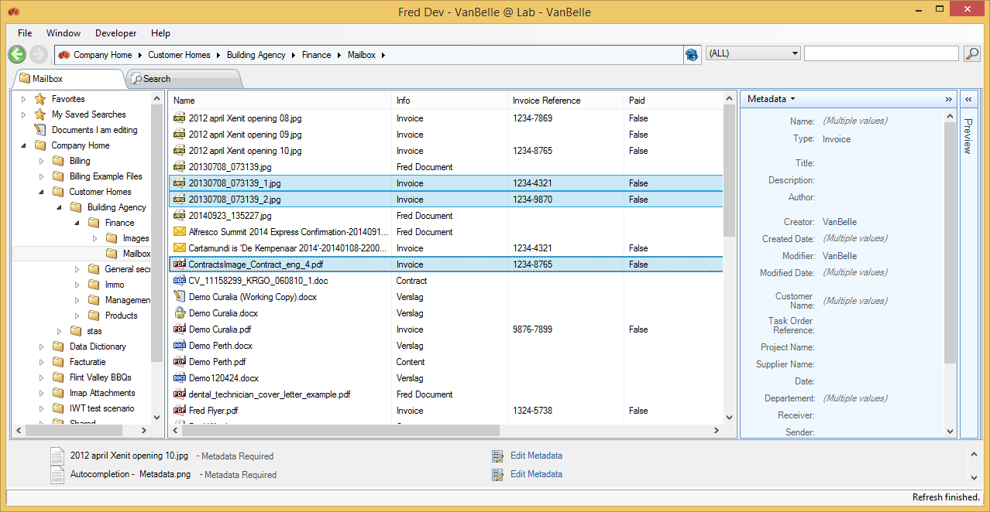

When you select the edit mode of the metadata pane, you are able to update the values of the common metadata fields. Please note following behaviour:

* Not filling in a field will not change the existing values in that field
* Filling in a value in a field will overwrite the existing values in that field

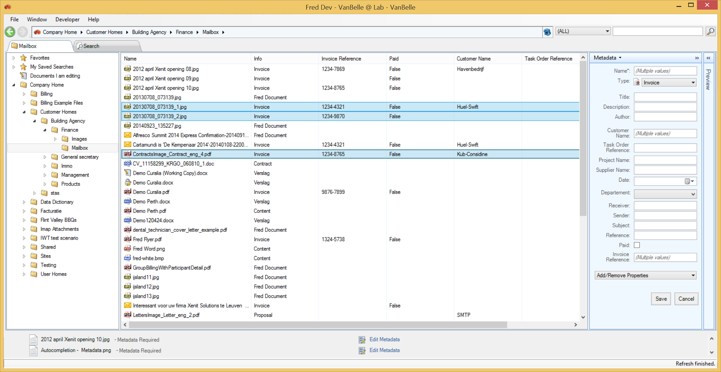

For categories following behaviour is defined:

* Checkbox  or  indicates that all documents have that value
* Checkbox  indicates that the selection contains multiple values.
* When clicking the checkbox, it will iterate between ,  and . This is indicating that you want to provide the field the new value  or , respectively that you want to leave the different values in the document selection unchanged.

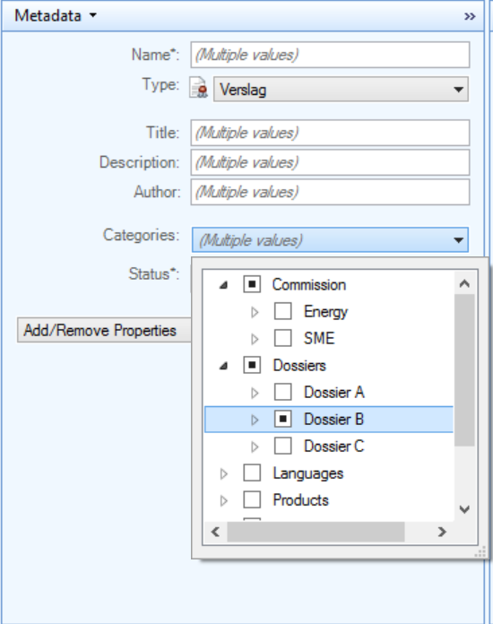

## Exporting metadata

In the detailed pane and the search pane, you can export the metadata of selected objects and save them to a comma separate file on your local drive.

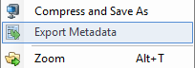 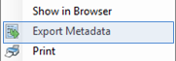

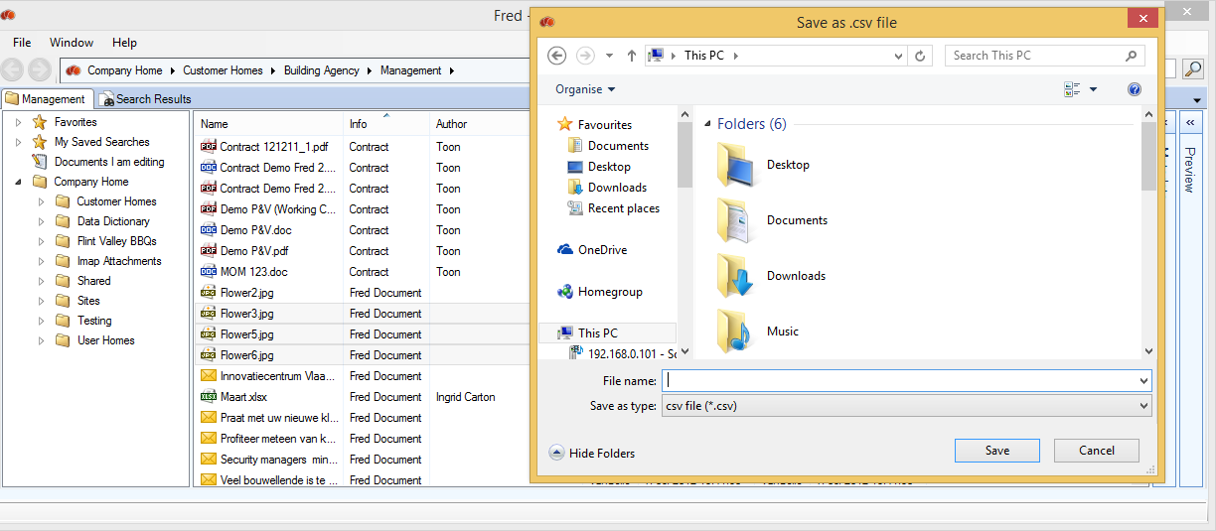

The metadata of the columns that you selected in the view will be exported to a local file.

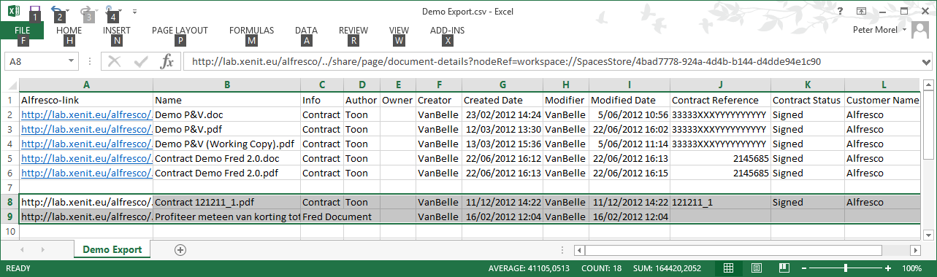

You can now add additional records to the list by selecting new objects and using the shortcuts CTRL + C or the COPY command to copy the metadata to the desktop clipboard. You can paste then the metadata values to an excel table.

You can configure is a hyperlink to the object should be added as first column. This parameter is set in the advanced tab of the Fred configuration: File>Open Settings

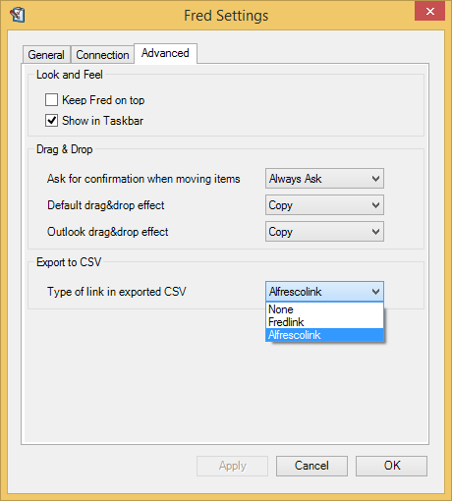

## Metadata governance – Mandatory metadata

When uploading documents to the server, standard document properties are extracted automatically from the document and you are invited to edit the business metadata. You can choose to keep the default document type and not to add extra metadata.

Adding extra metadata fields and values is helpful in finding back the content and providing extra views on the content. To guide the users in completing the appropriate metadata, you are able to add some additional metadata governance in specific folder structures.

This functionality needs to be properly configured on your server. Contact your IT team for this.

How the activate the metadata governance on a specific folder

You can activate the mandatory metadata governance on a specific folder and its subfolders by adding the Enable Metadata Aspect to the folder.

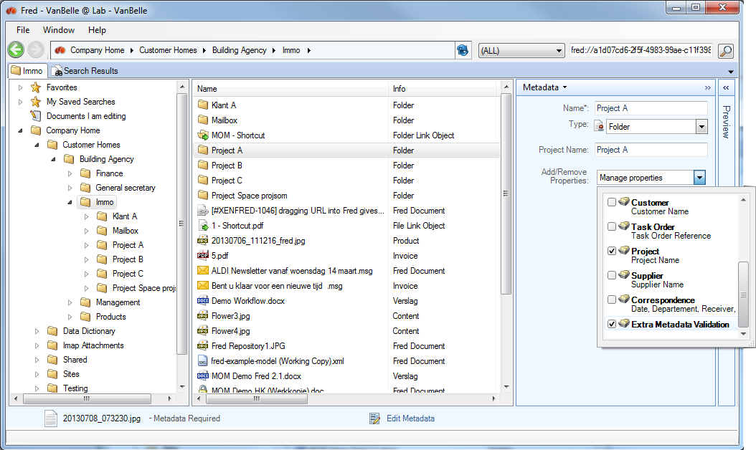

An indication that the Metadata Validation is activated is provided in the metadata panel of the folder as shown below.

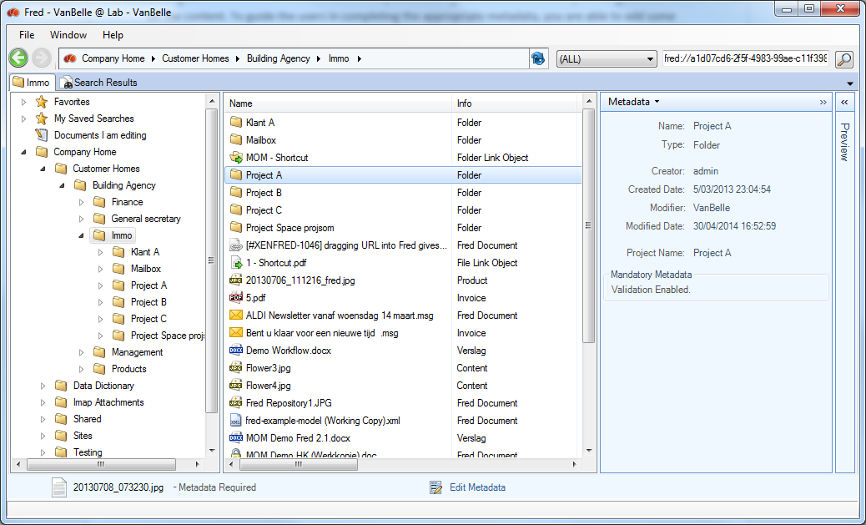

Metadata Validation behaviour

When the Metadata Validation is activated on a folder, following behaviour will be standard:

* You will be able to upload documents into this folder structure.
* Document for which the document type or the metadata values are not compatible with the metadata governance rules will remain visible in the upload progress pane until the metadata is completed correctly.
* When adding to many document with metadata that do not pass the validation check, you will be restricted from adding additional documents to the repository. The limit of number of ‘invalid’ documents is defined on the server.

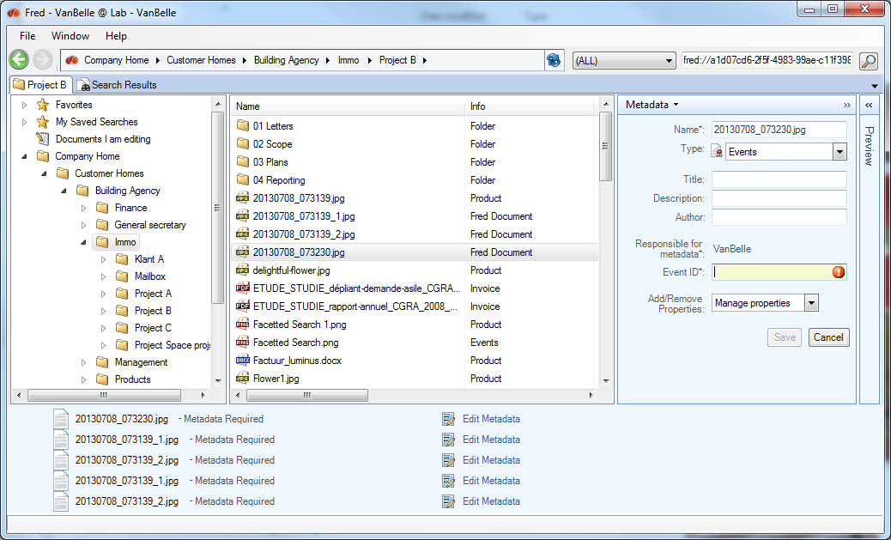

Metadata validation rules

* The document type cannot be generic (i.e. Fred Document, Company Document, …) and must be specified in detail (i.e. Invoice, Project, Minute Of Meeting, …). The list of ‘generic’ document types are defined on the server.
* For document types which contain mandatory metadata fields (indicated by a * next to the description), the fields must be completed with the appropriate values.

Behaviour with rules

When documents are uploaded in folders where automated rules are changing the document type and/or the metadata values, the validation check will run against the values after the rule has been executed. If the validation is positive, the document record will be removed from the upload pane after you have save the metadata.

Other people updating the metadata

When other people will complete the metadata, validation check will be positive and the document record will be removed from the upload list.

## Easy integration with third party metadata applications

Fred includes the possibility to connect to a metadata database or table, in which it can query metadata values linked to a record key (i.e. customer ID stored in Alfresco metadata field) in the database and present these values in presentation fields in the Fred User Interface.

For more information, contact your IT team.

# Handling views

## Show columns

In the Browse pane and the Search pane, you can add columns to the view by a right mouse click on one of the existing column headers, selecting “Show Column”. In that list you can select or unselect the field you want to present in the column.

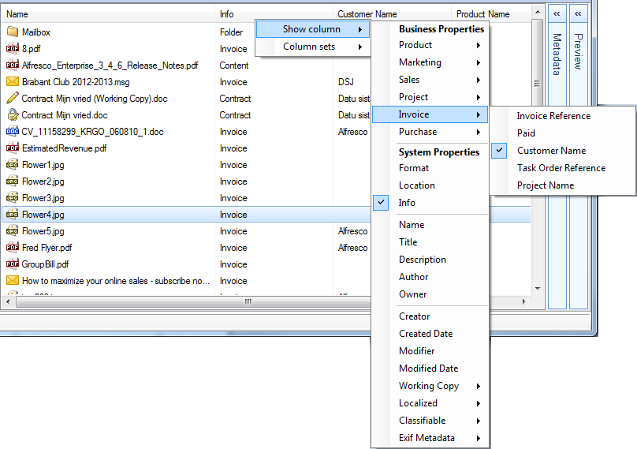

The list of fields is the summary of all metadata fields in all document types defined by your organization. You can modify the width of the column by dragging the edge of the column header. Notice that these modifications are persistent over the Fred sessions.

## Show a set of Columns

In the browse and search pane you can change your column view. Fred allows the selection of a predefined or custom defined set of columns.

The predefined column sets are all the document types defined in the Alfresco document model. Selecting one of these document types will show all metadata fields related to this document type in columns.

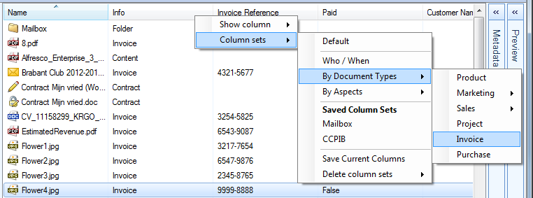

You can pick the individual columns you want to add in your custom view. This view will be set as the actual view and will be maintained when closing and reopening the repository.

## Creating personal views

You can select a specific set of columns and save this view with the “Save current Columns”. You will be prompted to provide a column set name. As from now, this column set will be available under “Saved Column Sets”.

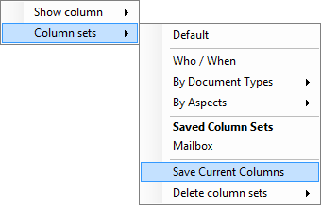 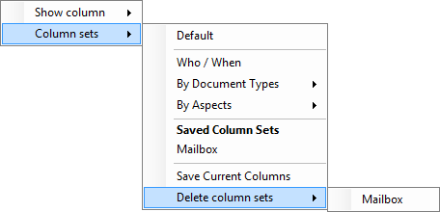

You can remove the custom column set by using the “Delete Column Sets” command.

## Sort on columns

Clicking on the column header will sort the files on alphanumeric values within the folder.

## Zoom

The Zoom function provides alternative and extended navigation functionality in a subpart of the folder structure. It is mainly used to provide a different view on the content in for example a project folder.

In a first version, Zoom provides an extra navigation structure based on the Category structure as defined on your Alfresco server.

Select the folder and click on Zoom.

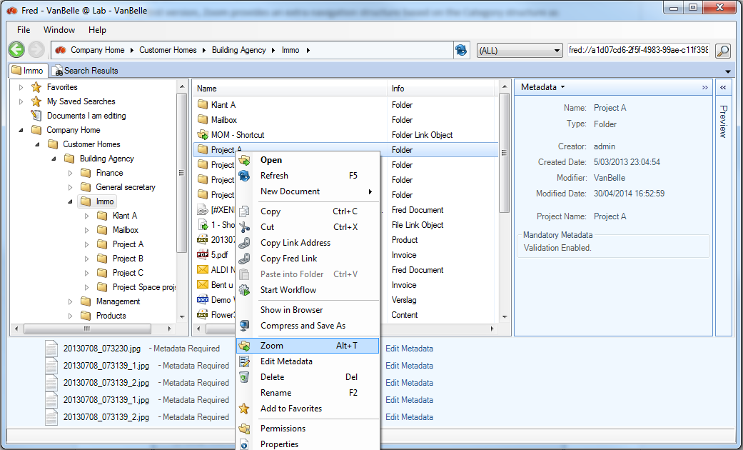

A separate tab will open where the selected folder will become the root folder and the sub folder structure is presented. All navigation and document functionality is available, provided you have the permissions in this sub structure.

The category structure is presented as an additional navigation structure. Selecting a folder will filter the content in the above folder structure and present the list in the Details pane.

In the example below, selecting Commission will present all document of project A which have been tagged with the categories ‘Commissies’, ‘Energie’ and ‘KMO’.

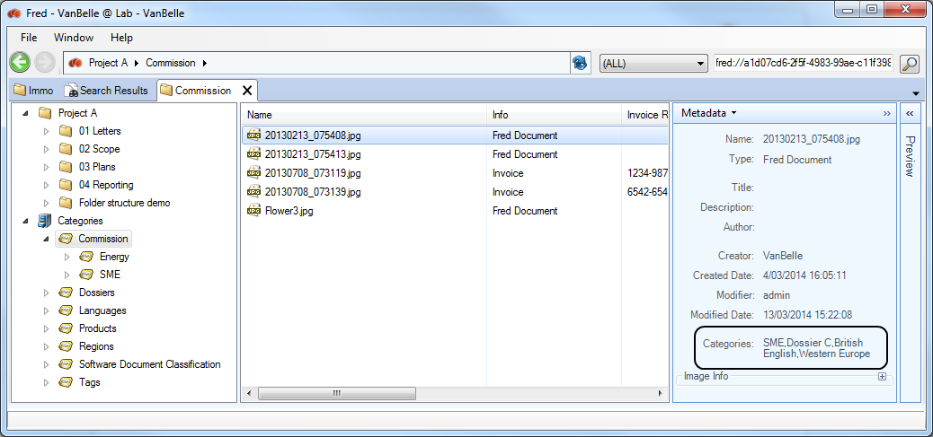

Uploading documents into the Zoom Tab

You can upload documents into a specific folder in the Zoom Tab.

You cannot upload documents when you are navigating in the Category structure as this does not indicate in which folder you want to upload the document.

## Virtual views

A Virtual folder is a filtered view on a part of the document repository. It allows to create a virtual folder structure based on filtered views on the repository.

Below is an example of views defined for an invoice approval process. The views are defined in configuration files in the Data dictionary. For each folder, one can define the filter, the folder icon, the columns, …

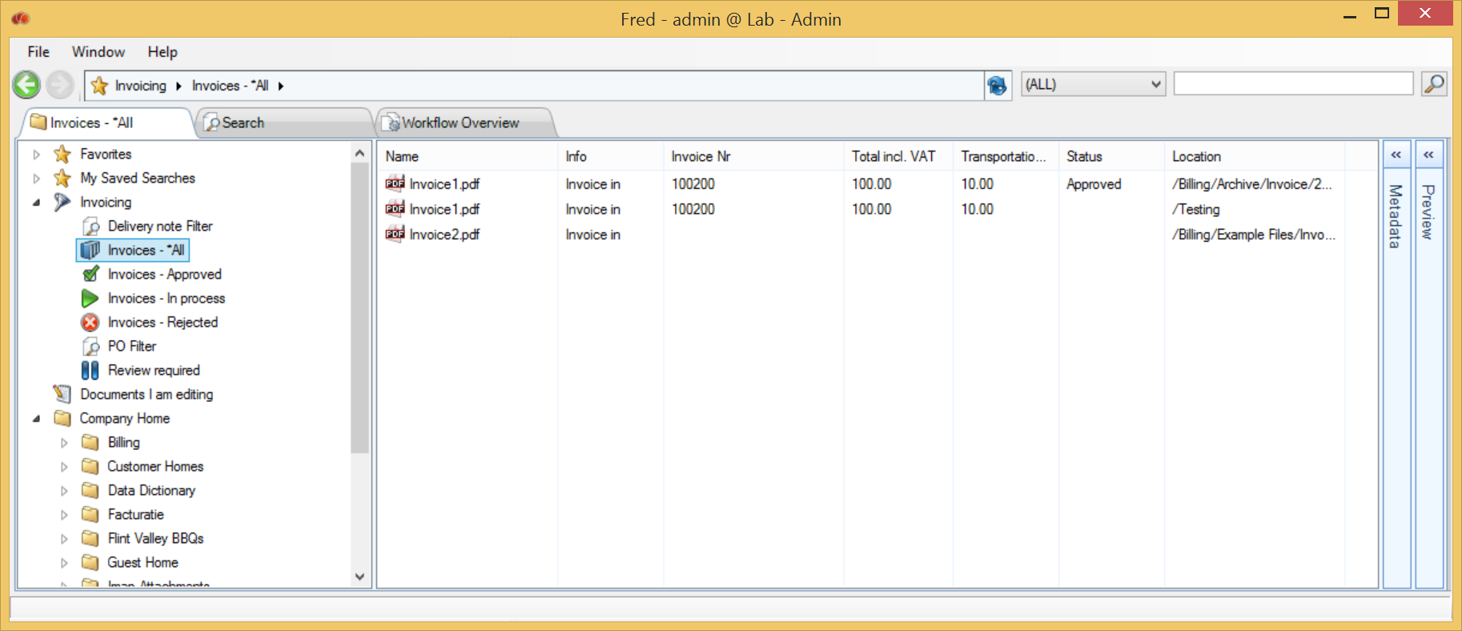

The ECM technical team can configure Virtual Views.

# Searching

## Simple search

At the top of the Fred Window you are able to type in any text you are looking for.



The search will look for the text in any metadata field and in the text of the document if it is text-searchable. The search will be restricted to the folder set in the breadcrumb and its subfolders.

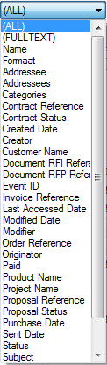

The generic search will look for this value in:

* Folder names
* File names
* Metadata fields
* Document searchable content
* Format

When selecting a metadata field, search will be restricted to this metadata field.

When selecting a “Full Text”, search will be restricted to searchable content.

Some simple rules to optimize the search result:

* Blanks between words will provide the search result where both words appear
* Use wildcards before and/or after the word (*health*) when you are looking for that text in a part of a metadata field, document, …

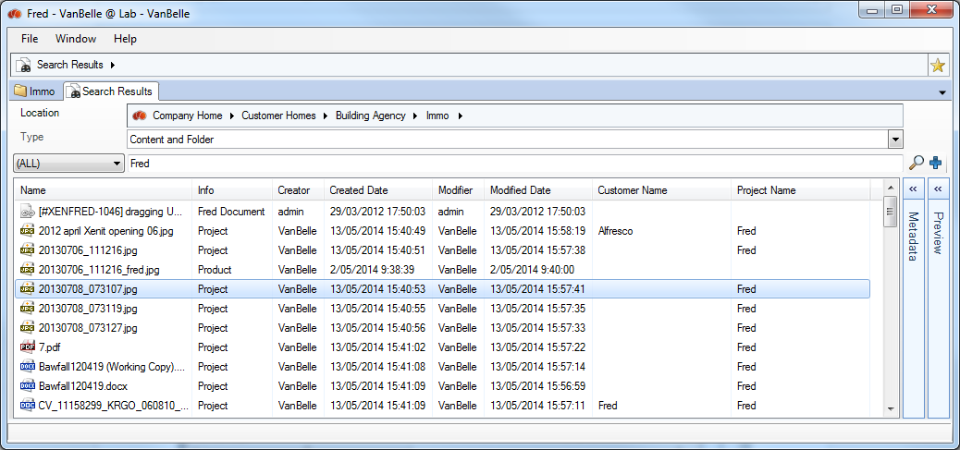

The search result will be presented in a separate tab as a list view and show all available field values of the selected columns. Again, you can select the column set you want to see and the list can be sorted by clicking on the column header.

## Dropping an Alfresco Link or Fred link in the Search field

If you have received an Alfresco or Fred link to an object, you will be able to copy and paste it into the Search field. You will get the object in the search result.

## Advanced search

The simple search can be extended to a more complex search. To add or delete search criteria, click on .

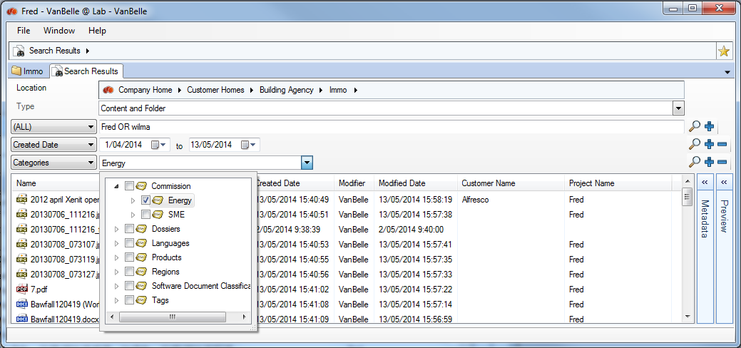

If you want to refine your search, you can add as many metadata fields as you want. Click on the  to execute the search.

## Facetted search

Where SOLR indexing has been activated on the Alfresco Server, one will get additional filtering functionality in the search result. On the left a list of facets and values of the search result will be presented.

The facets appearing in the left column are predefined by your organisation. Contact your IT team if you want to see extra fields appear in this list to optimize your search.

For each facet defined in the search pane, a list of values which appear in your search result and the number of records containing that value are presented.

Selecting one of the values will filter the search results to those documents containing the value. The facets pane will be updated to the new search result. The Facet fields and the number of records will be updated to those appearing in the filtered result.

In the example below, selecting Modifier VanBelle filters the search result to all documents modified by VanBelle and the facet values and the number of hits (Verslag from 21 to 19 hits) will be filtered to this content where VanBelle is the last modifier.

Selecting multiple facets, you can quickly narrow down the search result and find back the document you were looking for.

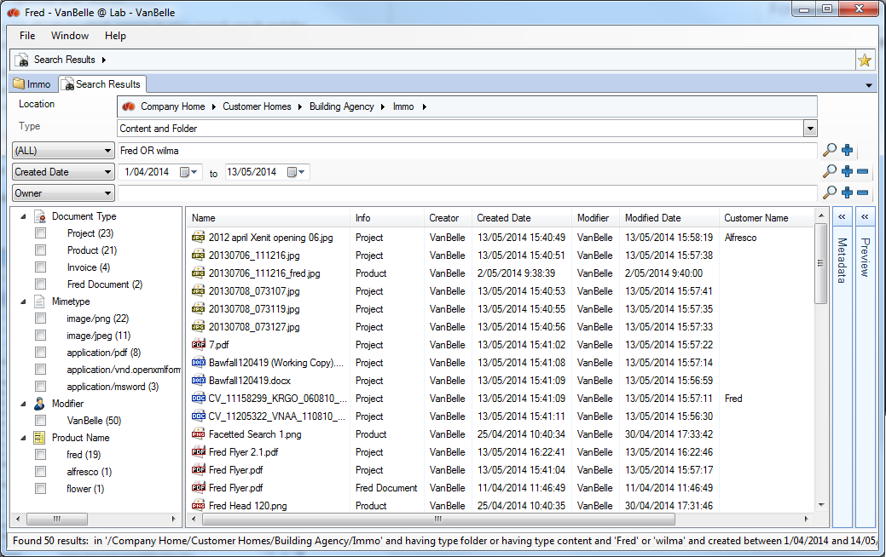

Filtering using facets.

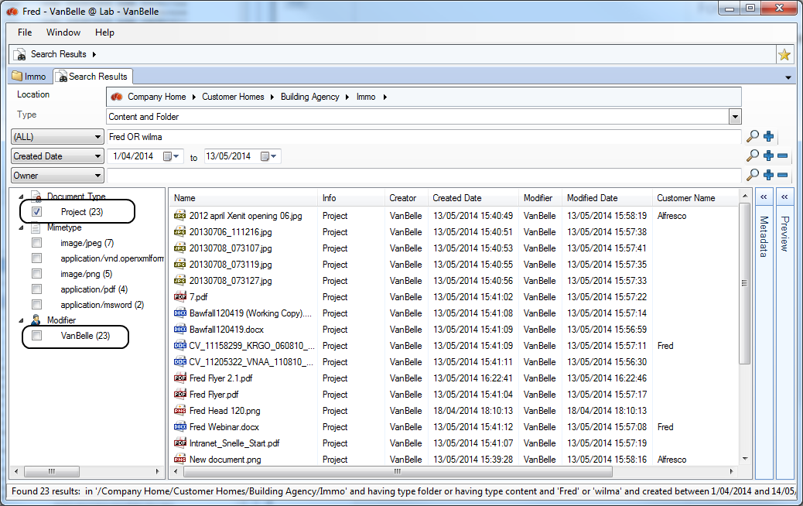

## AND, OR and () operators in text fields

In text fields, you can use OR, AND and () operators to make an advanced search on a specific field.

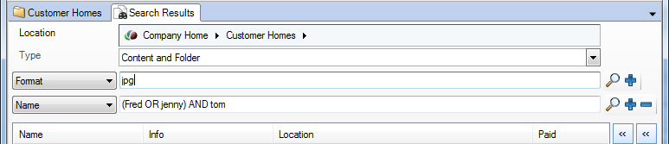

The behaviour in this field is as follows:

|  |  |  |
| --- | --- | --- |
| Input user | Presentation after pushing Enter | Search result |
| Tom Jerry | Tom AND Jerry | Tom AND Jerry |
| Tom OR Jerry | Tom OR Jerry | Tom OR Jerry |
| “Tom and Jerry” | “Tom and Jerry” | “Tom and Jerry” |
| Tom Jerry OR Goofy AND “Donald Duck” | Tom AND Jerry OR Goofy AND “Donald Duck” | ((Tom AND Jerry) OR Goofy) AND “Donald Duck”  (Tom AND Jerry) AND “Donald Duck”  Goofy AND “Donald Duck” |
| Tom Jerry OR (Goofy AND “Donald Duck”) | Tom AND Jerry OR (Goofy AND “Donald Duck”) | (Tom AND Jerry) OR (Goofy AND “Donald Duck”)  Tom AND Jerry  Goofy AND “Donald Duck” |

## Messages in search result (Enhanced)

The administrator can limited the search results on the Alfresco server. In case limits are triggered during the specific search action launched by the user, Fred will display a message that additional search results might be available.

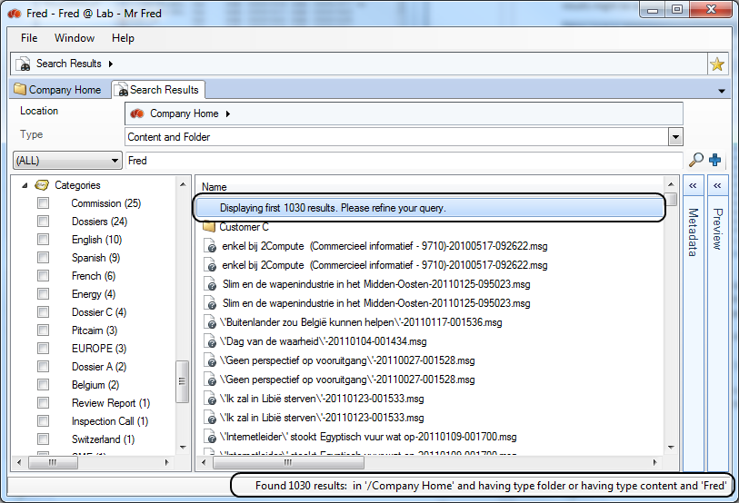

One can limit the time during which the search is executed and the number of results that are evaluated against access rights. If one of these limits set are met, search is stopped and the current result is evaluated against access rights and presented as the final search result.

A message is displays with an indication on how to proceed to get a better search result.

While executing a result, Fred is displaying multiple messages:

* At the left bottom:  
  While searching  
  When result is found 
* In the search tab:  
  While searching  
    
  When the result is found  
  

When you launch a new search while the previous search is still running:

* You will get a warning message  
  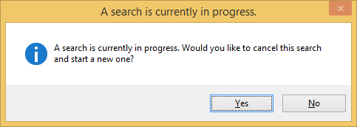
* If you confirm, then the running search will not be cancelled on the server but the result will not be presented in Fred. Instead Fred will present the result of the new search.

## Search in a part of the tree structure (Enhanced)

If you want to limit your search to a part of the repository, you can set the folder, in which you want to search. The search will be limited to the folder and its subfolders.

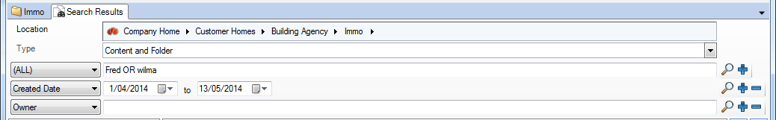

You can also select the Favourites folders as a location.

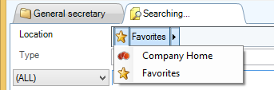 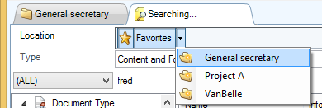

## Saved Search (Enhanced)

It is possible to save your current search by clicking on the star icon next to the search tab, usually in the upper right corner of the User Interface. Doing so, you can easily perform your search again in the future.

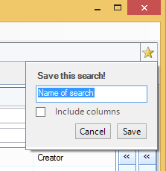 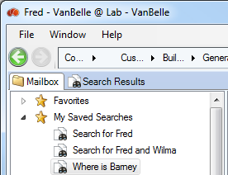

## Preview your search

When you select a document displayed in the result list of a search, the meta-data is shown directly in the meta-data pane as well as a preview of the selected file.

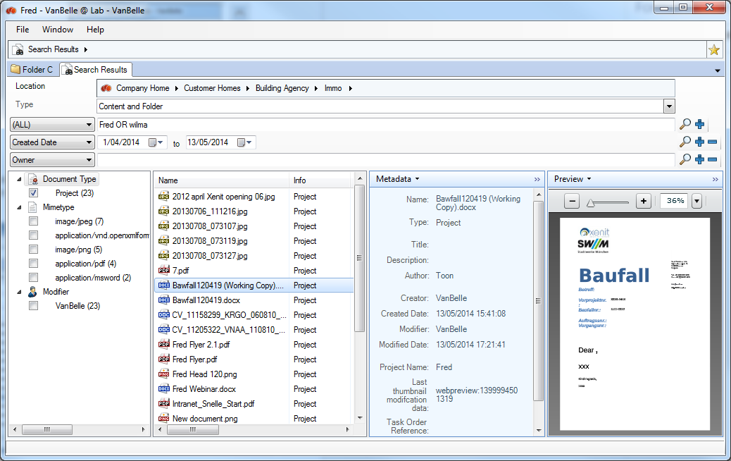

## Filter on columns

You can filter on the value in the column. You can add multiple values per column and you can put filters in different columns. The filter is set by selecting the value(s) and clicking “Add Filter”.

The filter value is removed by clicking the value in the list of Active filters.

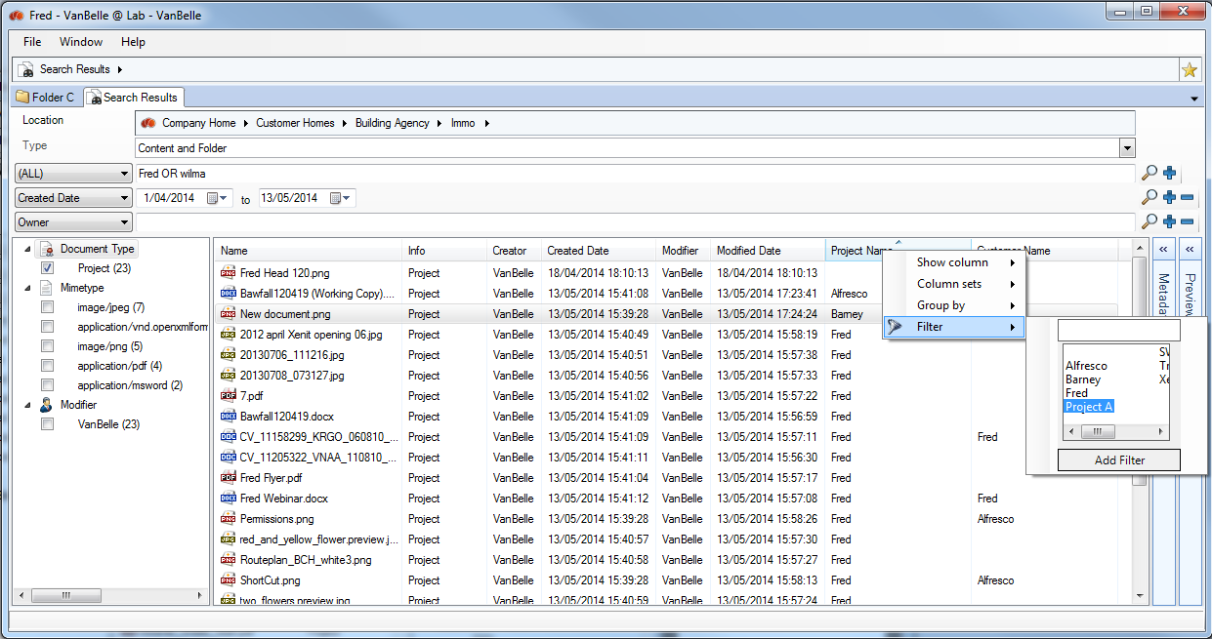

## Grouping on metadata values

You can group the search results on the values in one metadata field. Right click on the column header and select “Group by”.

Remove the grouping by deselecting the metadata field in the list.

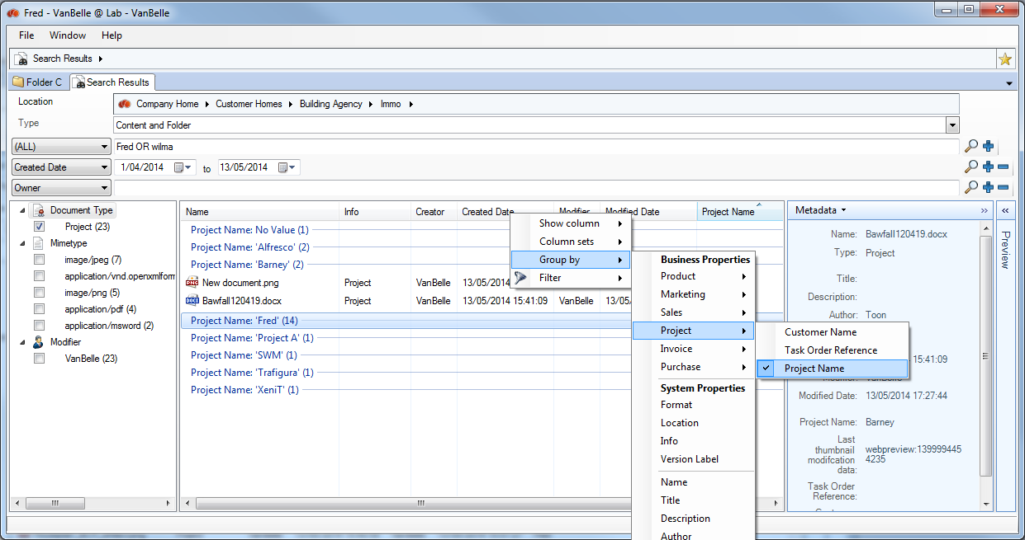

## Open file location

The search result is shown in a list view. Many of the file commands are available in the search pane.

Clicking “Open File Location” will show you the folder or file selected in the tree structure. This will allow you for example to find back the folder in which you have put a file and add a new file to the same folder.

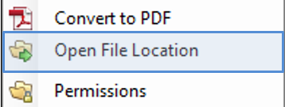

# Workflow

## Starting a workflow

In the repository you can launch a workflow from one or more selected content items, whether files or folders. Starting a workflow generates a workflow task for the persons who were assigned to the task.

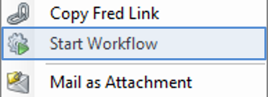

* Navigate the library’s folder structure to locate the item(s) you want to work with. These can be documents and/or folders.
* Select the item(s) of interest.
* Click Start Workflow.
* The Start Workflow tab appears.
* Expand the Workflow list and select the type of workflow you want to define.

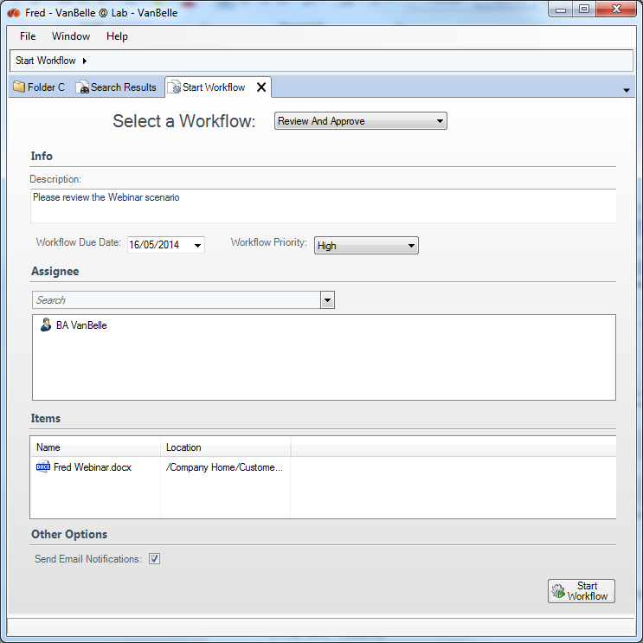

The following preconfigured workflows are available:

Adhoc

Let’s you assign a task to a single user

Group Review & Approve

Let’s you set up review and approval of content, assigning the workflow task to a single group

Parallel Review & Approve

Let’s you set up review and approval of content, assigning the workflow task to multiple users

Pooled Review & Approve

Let’s you set up review and approval of content, assigning the workflow task to multiple users. One user can take ownership of the task at a time, completing it or returning it to the pool to be claimed by another user associated with the task.

Review & Approve

Let’s you set up review and approval of content, assigning the workflow task to a single user

The appropriate workflow form displays where you enter the details of the workflow task being initiated. Required fields are marked with an asterisk (*).

* Provide the basic details for the workflow task in the Information section.
  + In the Description field describe what you want the recipient of the task to do, such as: “Please review the attached content”. This text displays in the My Tasks table of the workflow overview for this workflow task. This content should clearly explain to the user what they are expected to do with the related content item(s).
  + Click the icon to the right of the Workflow Due field to specify the completion date for the task.
  + Select a Priority setting for the task.
* You assign the task to either a user or a user group depending on the type of workflow selected.
  + In the Assignee section type in the name of the user or group and push Enter. Fred will present a selection of users and groups which match you search criteria.

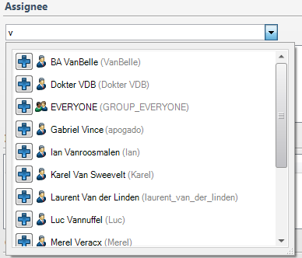

* + Click Select  to the left of a user or group to select it.
  + For tasks with groups and multiple users you must complete the Required Approval Percentage field. Indicate the percentage of reviewers that must approve the task in order for the entire workflow task to be considered complete.
* Enable the Send Email Notifications setting in the Other Options section to have the application automatically send an email each time a task is assigned to a user as part of this workflow.  
    
  Tasks generated by the workflow will still appear in the user's My Tasks list in the Workflow Overview. The email is sent to the email address listed in the user's profile. If an address is not provided, no email will be sent.  
    
  For group and pooled tasks, every member of the selected group will receive the email notification.
* Click Start Workflow.
* The workflow task is created. A record will appear in the My Tasks list and the Workflows I’ve Started list of the appropriate users.

## Workflow overview

The workflow overview provides you a view on the Tasks assigned to you and the workflows you have started.

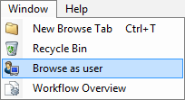

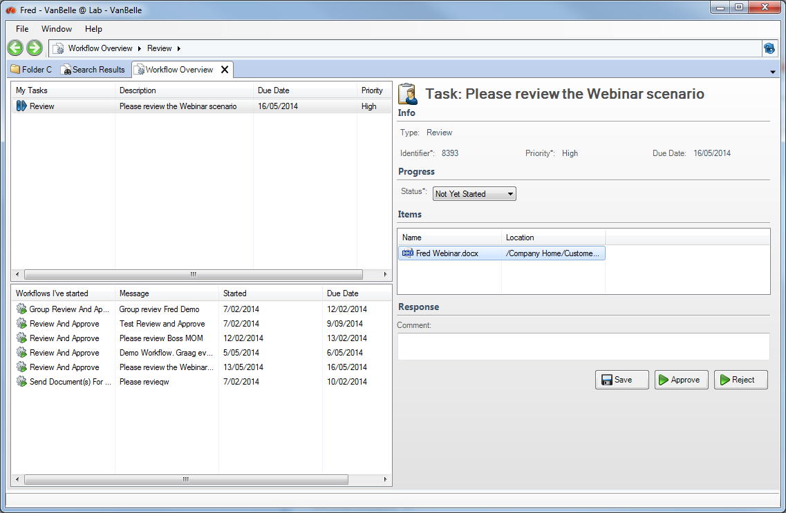

Left upper pane is a list of all actions that are assigned to you.

Left lower pane is a list of all workflows you have launched.

Right pane provides a detailed view of the task or the workflow you have selected on the left side.

## My Tasks

The My Tasks list lets you view and manage the tasks that are assigned to you. You can sort the list of tasks by clicking on the column header. Selecting a task will show the details of the task in the right pane.

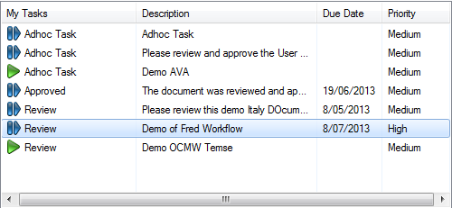

The summary provided for each task includes:

* current status of the task
* task type
* task name
* due date
* priority

## Editing a task

Each task is your responsibility and remains assigned to you until you manage it.

In the task list locate the task you want to work with and select it. In the right pane, the details of the Task are presented. The actions available on this page depend on the task type.

Manage the selected task in one or more of the following ways:

Update: If the task is in progress but not yet complete, you can change the task status and add a comment indicating your progress, then click Save and Close. The task remains assigned to you.

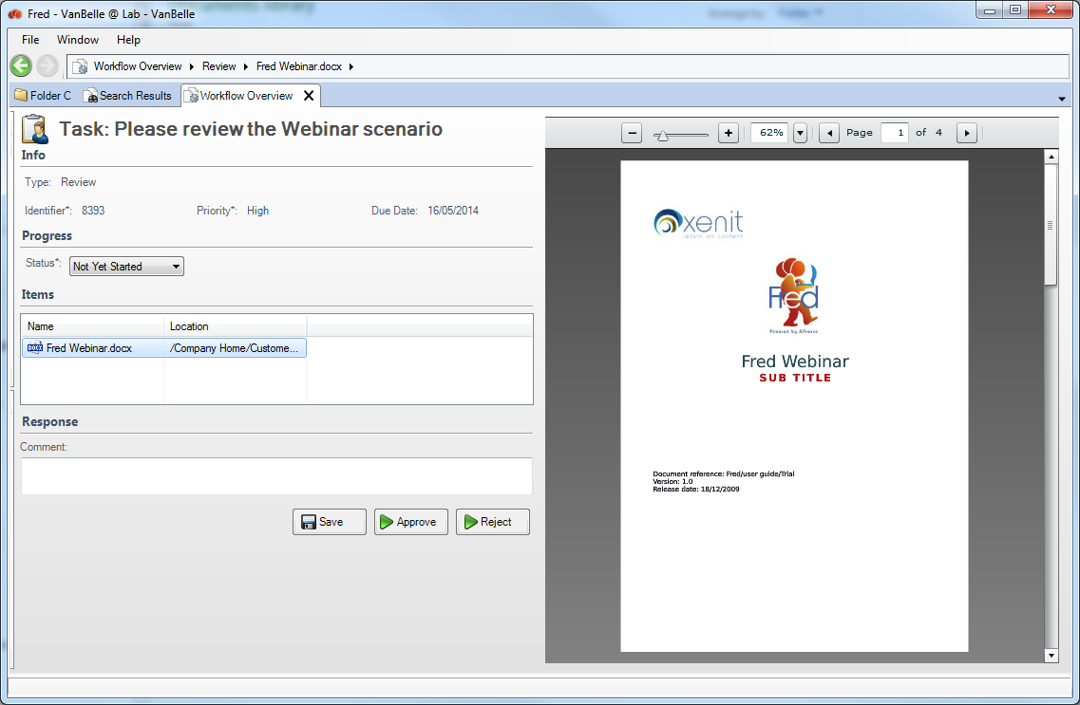

Approve or Reject: When you are done with a task you can update the task status, add a comment indicating the work done, and then click either Approve or Reject. The task returns to the user who started the workflow and no longer appears in your task list.

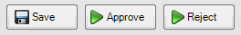

Claim: Click Claim to take responsibility for a pooled task. This action is available only for pooled tasks that are not yet assigned.

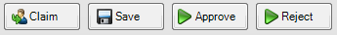

Release to Pool: Click Release to Pool to place a task back in the pool. The task then appears in the task list as Unassigned and can be claimed by another user. This action is available only for pooled tasks that are currently owned by you.

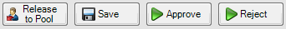

Task Done: Once a task is complete, it is returned to the user who started the associated workflow. Click Task Done to finish a task and remove it from your task list.

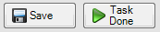

Once the selected action is complete the task will be removed from the My Task list. A new task will appear in the My Task list of the person that launched the workflow to confirm that the workflow has been completed.

## Overview of the documents

It is possible to configure the metadata columns in the Items list and group the linked documents based on a metadata field value. In the below example, an invoice and related purchase orders are presented to the person that needs to approve the invoice. One can for example show the Total Amount related to the documents.

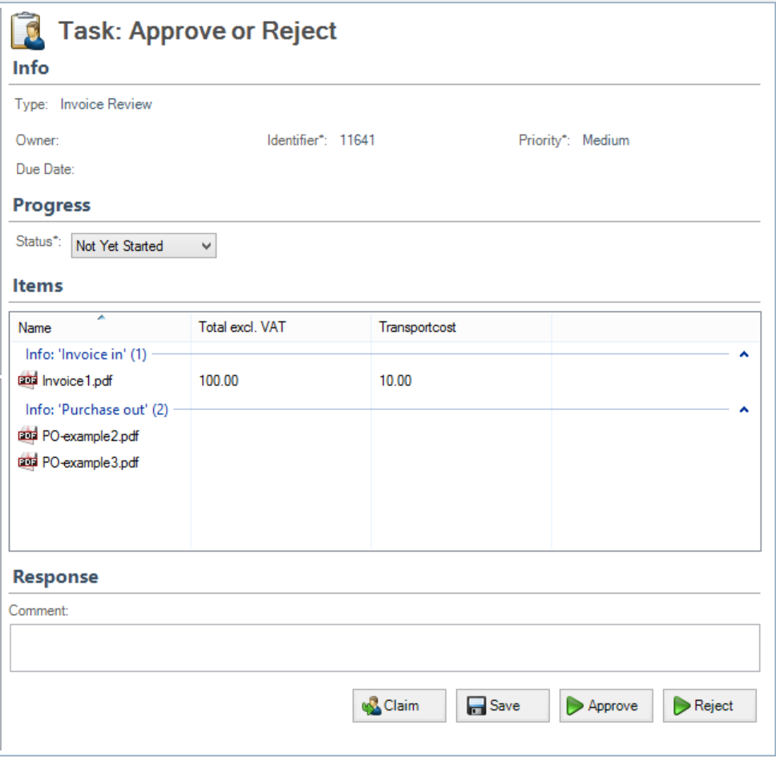

The ECM technical team can configure the Columns and the grouping.

## workflows I’ve started

From the Workflows I’ve Started list, you can view the full details of a workflow, including a workflow summary, details on the most recently completed task, and a summary of all tasks generated by the workflow.

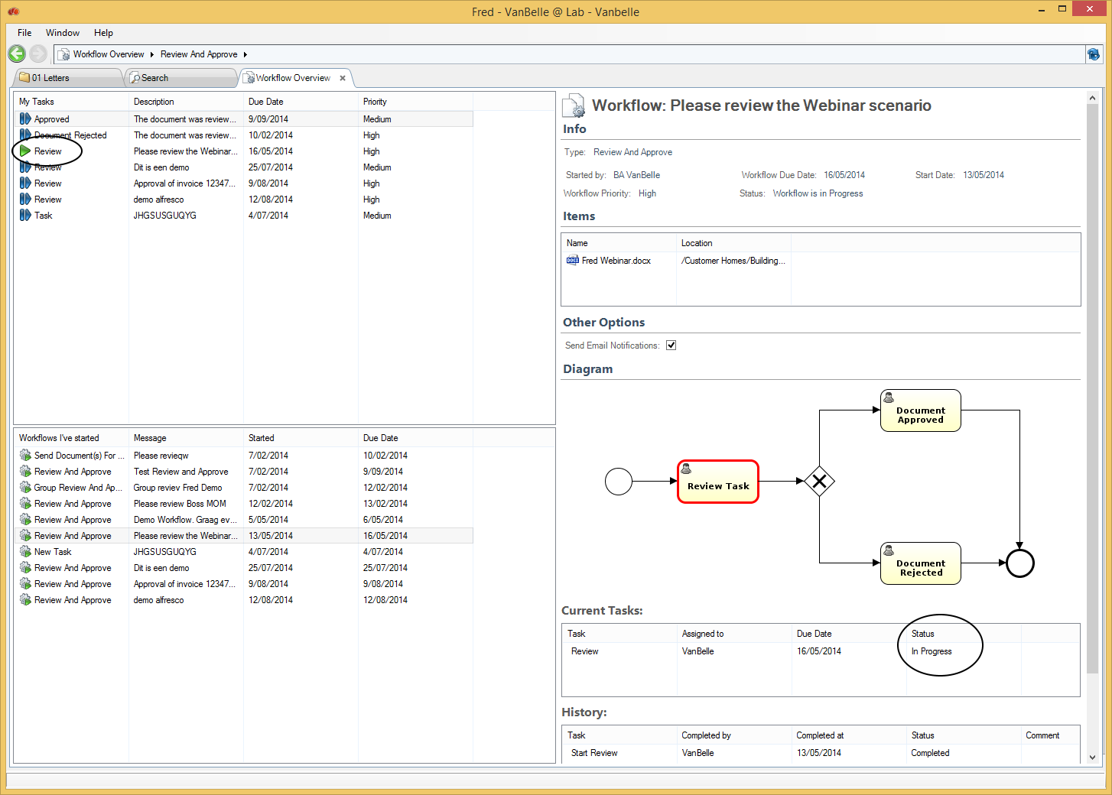

The summary provided for each workflow includes:

* workflow type
* workflow name
* date started
* due date

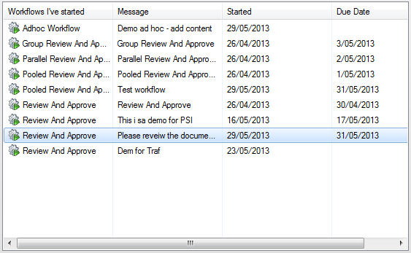

Viewing a workflow lets you confirm you have selected the correct one before you cancel it.

In the list workflow I’ve Started select the workflow you want to review in detail.

The Details page appears displaying the information for the selected workflow.

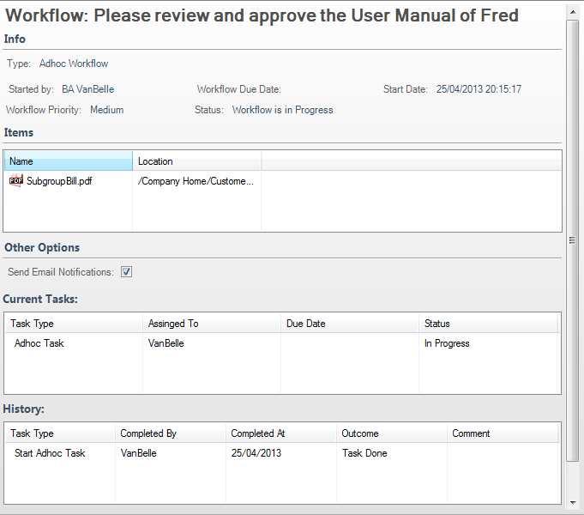

Current Tasks:

Overview of the open tasks related to this workflow. Clicking on a task in this list will provide you a detailed view of the task.

To return to the Workflow Detail view, click on 

History:

Overview of the tasks that have been executed until now. Clicking on a task will provide you a detailed view of the task.

To return to the Workflow Detail view, click on 

## Cancelling a workflow

Cancel an existing workflow when it is no longer required. This deletes all tasks related to the workflow.

In the workflow list locate the workflow you want to cancel. In the Workflow details pane, click Cancel Workflow.

The selected workflow is cancelled and removed from the workflow list. All tasks related to the workflow are deleted, which removes them from the assignees’ task lists.

# Additional user functions

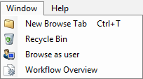

## New Browse Tab

You can open multiple Browser tabs. Each tab will describe the active folder in the tab. You can also use the shortcut CTRL+T to open a new tab.

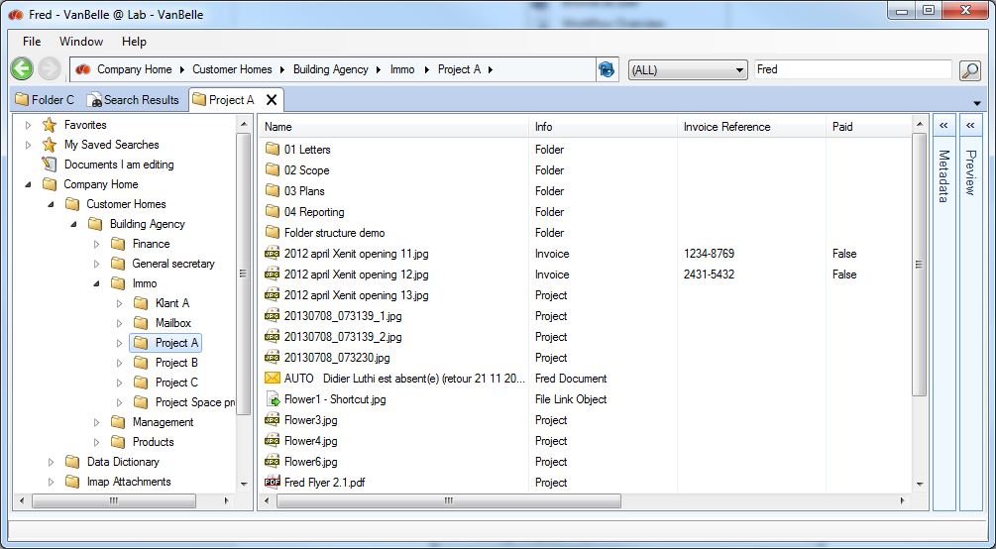

## Recycle bin

The recycle bin enables you to restore deleted files and folders, similar to the Windows Recycle Bin.

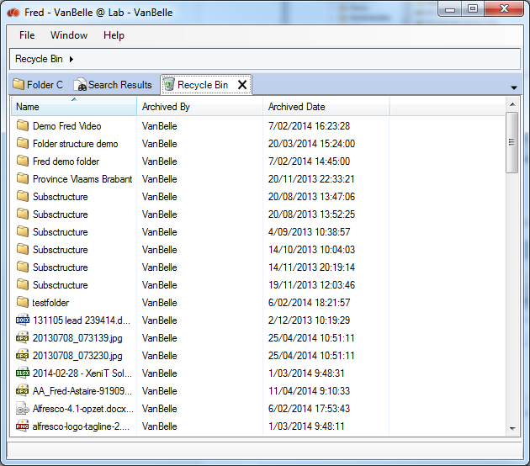

## Browse as user

Only the general Alfresco ECM Administrator will have following functionality available.

Administrators can impersonate another user. The administrator can see what a user can see, to troubleshoot permissions, for example.

* Open the Windows Menu and click the “Browse-as-User”-command and a Browse as user tab will open.
* In the upper textbox, fill in the Alfresco username and click on “Switch User”.
* The specified user has at least consumer (=read) access to the folder structure and documents presented.



# Fred User Settings

Fred allows you to configure following settings listed below. To change the settings, click on “File” and select “Open Settings”.

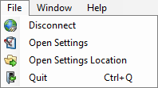

## General

Localisation

* Fred will use by default the language set in Windows. You can set a specific language pack for the Fred user interface.
* Fred Working Directory is the folder used to download the working copies in the edit offline action.
  + The checkbox ‘Clean up Temporary files on disconnect’ activates the removal of temporary copies of downloaded files. As you continue to consult documents, temporary copies remain on your local drive and grow in volume.
  + The checkbox ‘Ask to Check in working copies on disconnect’ activates the message box which will ask you to check-in all working copies when disconnecting from the repository. This is handy when you are working on two computers and you want to move from one to the other.

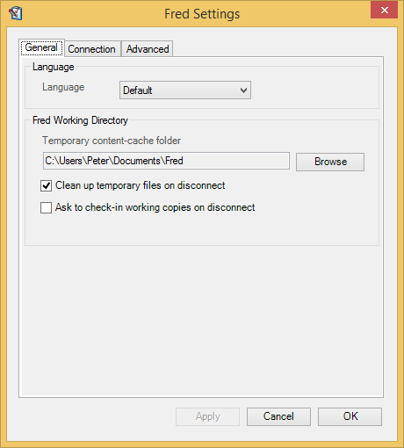

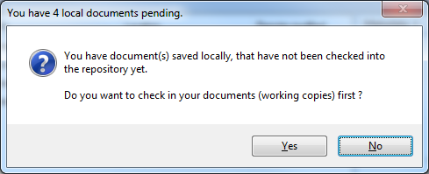

## Connection

Proxy settings

* Fred is enabled to handle proxy configuration. Contact your administrator for more information.

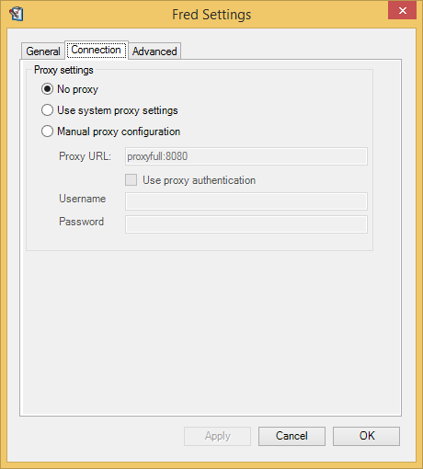

## Advanced

The settings in the advanced tab allow you to configure the behaviour of the Fred window.

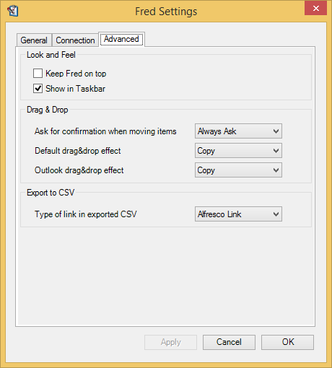

Look and Feel

Keep Fred on top: keeps the Fred window on top of all application windows. This will allow you to drag and drop files from another application directly into the Fred window.

Show in taskbar: presents a Fred tab in the Windows taskbar, not only in the system tray. Right mouse click on the icon  will provide a command menu.

Drag & Drop

Drag & Drop: Allows you to configure confirmation prompts and which default action should take place when performing a drag and drop form the Windows desktop and Explorer or the MS Outlook application.

Drag & Drop

When you export metadata from the navigation details or the search details, you can select to copy the Alfresco or Fred link of the object as first column in the csv list. As such, you can jump to the object from the list.

# Enterprise configuration capabilities

Fred has multiple corporate configuration capabilities. The IT team can adapt the configuration files and modify the behaviour in the user interface.

## Configuration of metadata pannel

One can define which fields are presented in the metadata view and edit pane. One can define the layout of the fields that are presented. Below is an example how you can collapse a number of fields which might be less relevant in the day to day activities.

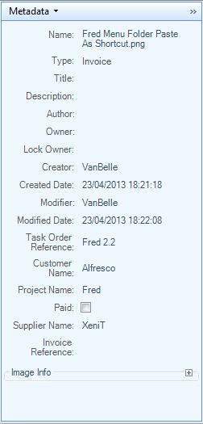 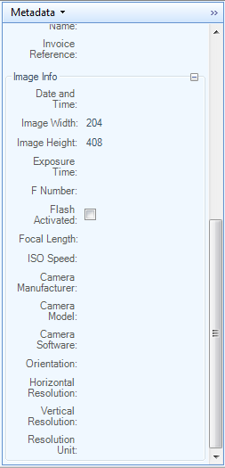

## ConfigurAtion of context menus

It is possible to adapt, reorder and extend the context menus in the Fred User Interface.

## Configuration of searchable properties

One can configure the list of fields that will be made available in the search field drop down.

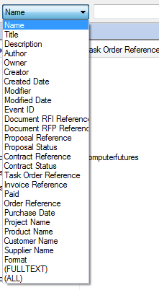

One can also configure which facets are presented in the search results.

## Configuration of metadata behaviour at creation of documents

At the creation of a document from a template, one can determine the behaviour of the metadata. For example:

* metadata will have to be provided afterwards

or

* metadata will have to be provided before the creation. This metadata can then be used as field values in the document. Example status of the document (draft, approved), date of the meeting, …

# General

## Integration with 3rd party applications:

It is possible to integrate 3rd party applications in the Fred user interface. The 3rd party application must be installed separately in your network environment.

One application have been integrated with the Fred User Interface:

* PDF Digital Signature application

The command in the file menu will launch the application. The file is send to the application and a new Tab is opened providing a view on the 3dr party application.

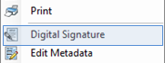

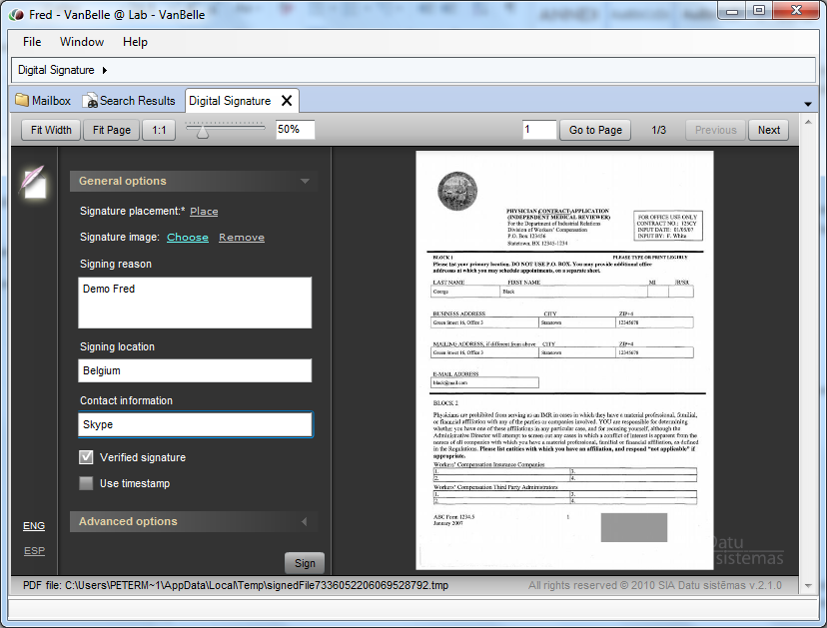

## local persistent caching

Fred provides persistent local caching of the metadata. As you browse the repository, metadata are cached and remains available to obtain a faster navigation and search experience. The cache is refreshed regularly as you navigate and search through the repository. You can at any moment force to refresh the cache by clicking F5 or the Refresh command.

# Reporting a problem

When a problem occurs, you can report it to your local IT helpdesk or to [support@xenit.eu](mailto:support@xenit.eu). The Fred team will be able to help you faster if you are able to provide following information:

* A description of your desktop environment: Windows version, application version
* The Fred version
* A description of the problem
  + A screenshot is very helpful
* Log files: you can find the log files by “Files/Open settings location”.
  + A list of log files appears. Attach the log files app-log4net.log and app-log4net.log1 to your report

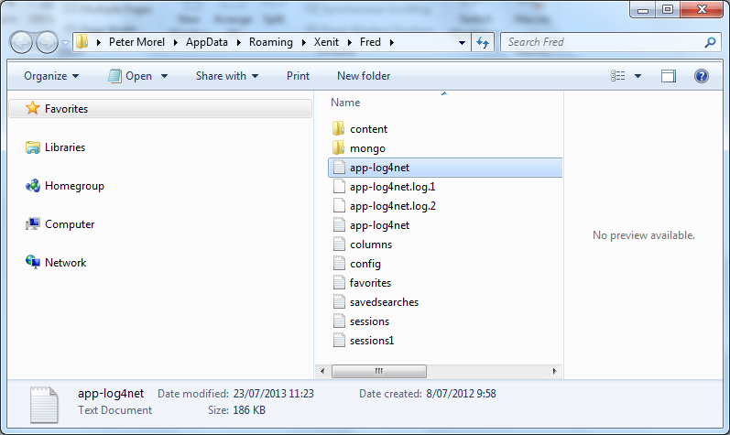

To help the user to report a problem, a ‘Report a problem’ command has been added to the Help menu.

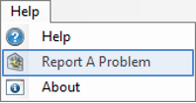

Clicking this command will open your default mail application and attach the log files to it. You need to complete the description of the use case and send it off to your Fred support team.